National Youth Ballet’s Performance Company auditions are now open!

**OUR MISSION:**

| * *We bring young people together* |  |
| --- | --- |
| * *We do creative, joyful and inclusive ballet* |  |
| * *We build**confidence, skills and positive values* |  |
| * *Young people achieve* |  |
| * *Young people give ideas for the future of ballet* |  |

**WHAT IS OUR PERFORMANCE COMPANY?**

* The dates are: **Sunday 10 August 2025 - Saturday 16 August 2025**

| * For young ballet dancers aged between 9 and 18 |  |
| --- | --- |
| * Location is Elmhurst Ballet School |  |
| * Lasts for seven days |  |
| * You can sleep at Elmhurst Ballet School |  |
| * You will work together as a group |  |
| * You will dance and learn new steps |  |
| * You will build confidence |  |
| * You will perform at the end |  |

**AUDITIONS**

: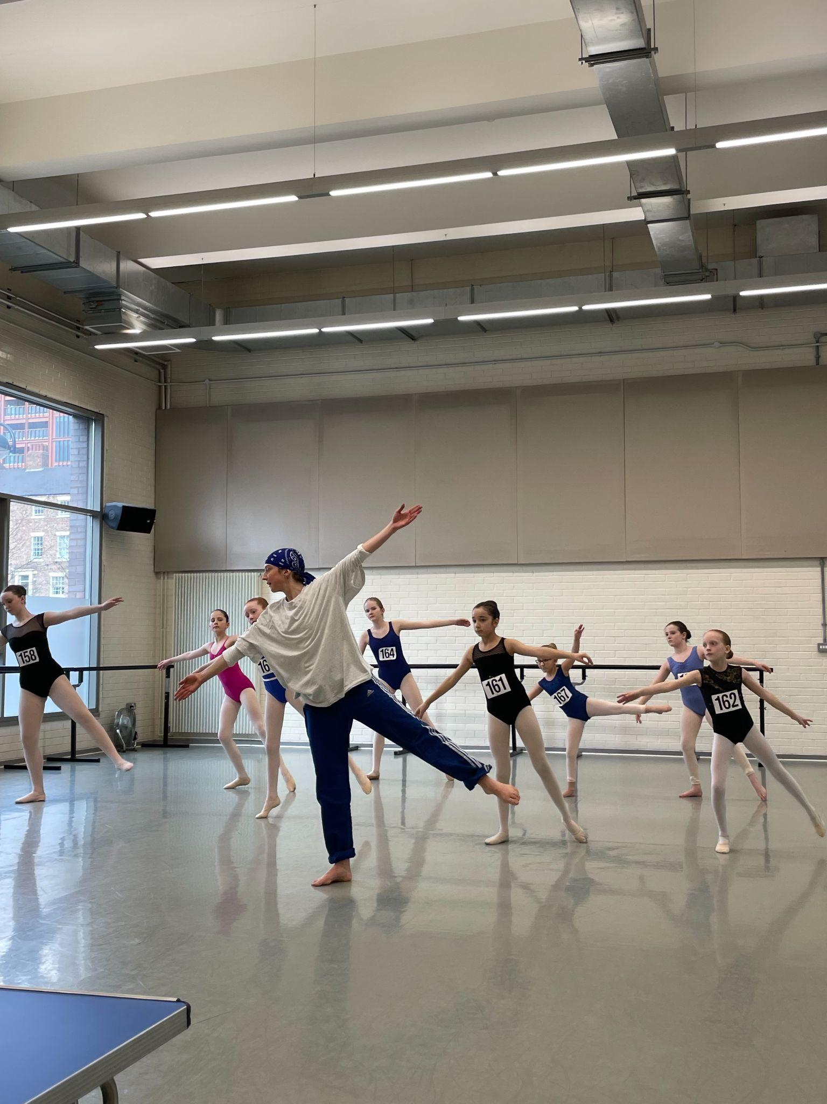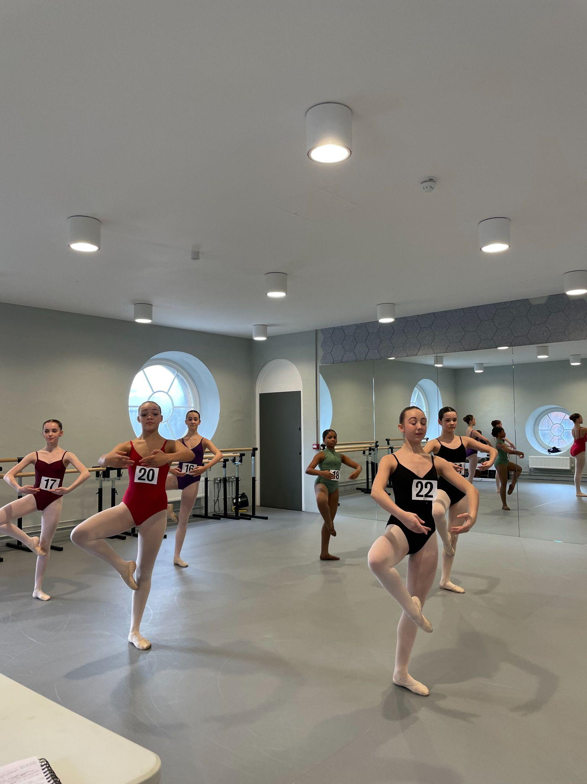

* You can now audition to take part in our Performance Company 2025!
* There will be seven auditions
* These auditions will be in different places in the country

**What will the audition involve?**

| * Time to settle in |  |
| --- | --- |
| * A ballet class |  |
| * A contemporary class |  |
| * All auditions will be filmed |  |

**Where can I audition?**

| You can audition in person in:   * Leeds * Birmingham * Newcastle * London * Bath |  |
| --- | --- |
| * Or you can audition online |  |

**What are the audition dates?**

| **Audition Venue** | **Audition Date** | **Application Deadline\*** | **Application form:** |
| --- | --- | --- | --- |
| **Leeds\***- Northern Ballet,  LS2 7PA | Sunday 26 January 2025 | Monday 20 January 2025 | <https://www.tickettailor.com/events/thenationalyouthballetofgreatbritain/1488309> |
| **Birmingham * -** Birmingham Royal Ballet, B5 4AU | Sunday 9 February 2025 | Monday 3 February 2025 | <https://www.tickettailor.com/events/thenationalyouthballetofgreatbritain/1443977> |
| **Newcastle** - Gateway Studio,  NE8 1EP | Sunday 16 February 2025 | Monday 10 February 2025 | <https://www.tickettailor.com/events/thenationalyouthballetofgreatbritain/1488312> |
| **London\*** Acosta Dance Centre, SE18 6BH | Sunday 23 February 2025 | Monday 17 February 2025 | <https://www.tickettailor.com/events/thenationalyouthballetofgreatbritain/1488320> |
| **Bath** - Bath Dance College,  BA3 3QG | Sunday 2 March 2025 | Monday 24 February 2025 | <https://www.tickettailor.com/events/thenationalyouthballetofgreatbritain/1488315> |
| **London** - London Vocational Ballet School, W12 8AP | Sunday 9 March 2025 | Monday 3 March 2025 | <https://www.tickettailor.com/events/thenationalyouthballetofgreatbritain/1488323> |
| **Online \*** - Zoom | Sunday 16 March 2025 | Monday 10 March 2025 | <https://www.tickettailor.com/events/thenationalyouthballetofgreatbritain/1488325> |

*\* Accessible venue*

Please see our Frequently Asked Questions for more information:

[Easy Read FAQs](https://nationalyouthballet.org/wp-content/uploads/2024/12/National-Youth-Ballet-of-Great-Britain-Residential-Performance-Company-2025-Easy-Read-Auditions-FAQ-1.docx) Word Document

[Easy Read FAQs](https://nationalyouthballet.org/wp-content/uploads/2024/12/National-Youth-Ballet-of-Great-Britain-Residential-Performance-Company-2025-Easy-Read-Auditions-FAQ.pdf) PDF Document



**Access Support for applications**

* A video description of this information can be found [**here**](https://vimeo.com/1035193034)**.**
* If you need help with the form please contact us at [**admin@nationalyouthballet.org.uk**](mailto:admin@nationalyouthballet.org.uk)
* You can share your access needs in our form
* You can share an access rider
* There is a description of how to make an access rider on this website page: <https://weareunlimited.org.uk/resource/creating-your-own-access-rider>



**Audition Cost:**

* Non-refundable audition fee: £40

**Performance Company Cost:**

* Stay at Elmhurst: £846
* Stay at home: £660

**Help to pay:**

* We can help you to pay course fees
* You need to fill out [this form](https://forms.gle/JxGpFJV32vdUsTBs8) if you need help with your fees
* The deadline for the form is: Friday 21 March 2025.
* If you need support with the form please contact us at: [**admin@nationalyouthballet.org.uk**](mailto:admin@nationalyouthballet.org.uk)