Frequently Asked Questions - Easy Read

**What is the 2025 opportunity?**

| * For young ballet dancers aged between 9 and 18. |  |
| --- | --- |
| * Location is Elmhurst Ballet School |  |
| * Lasts for seven days |  |
| * You can sleep at Elmhurst Ballet School |  |
| * You will work together as a group |  |
| * You will dance and learn new steps |  |
| * You will build confidence |  |
| * You will perform at the end |  |

**Auditions:** 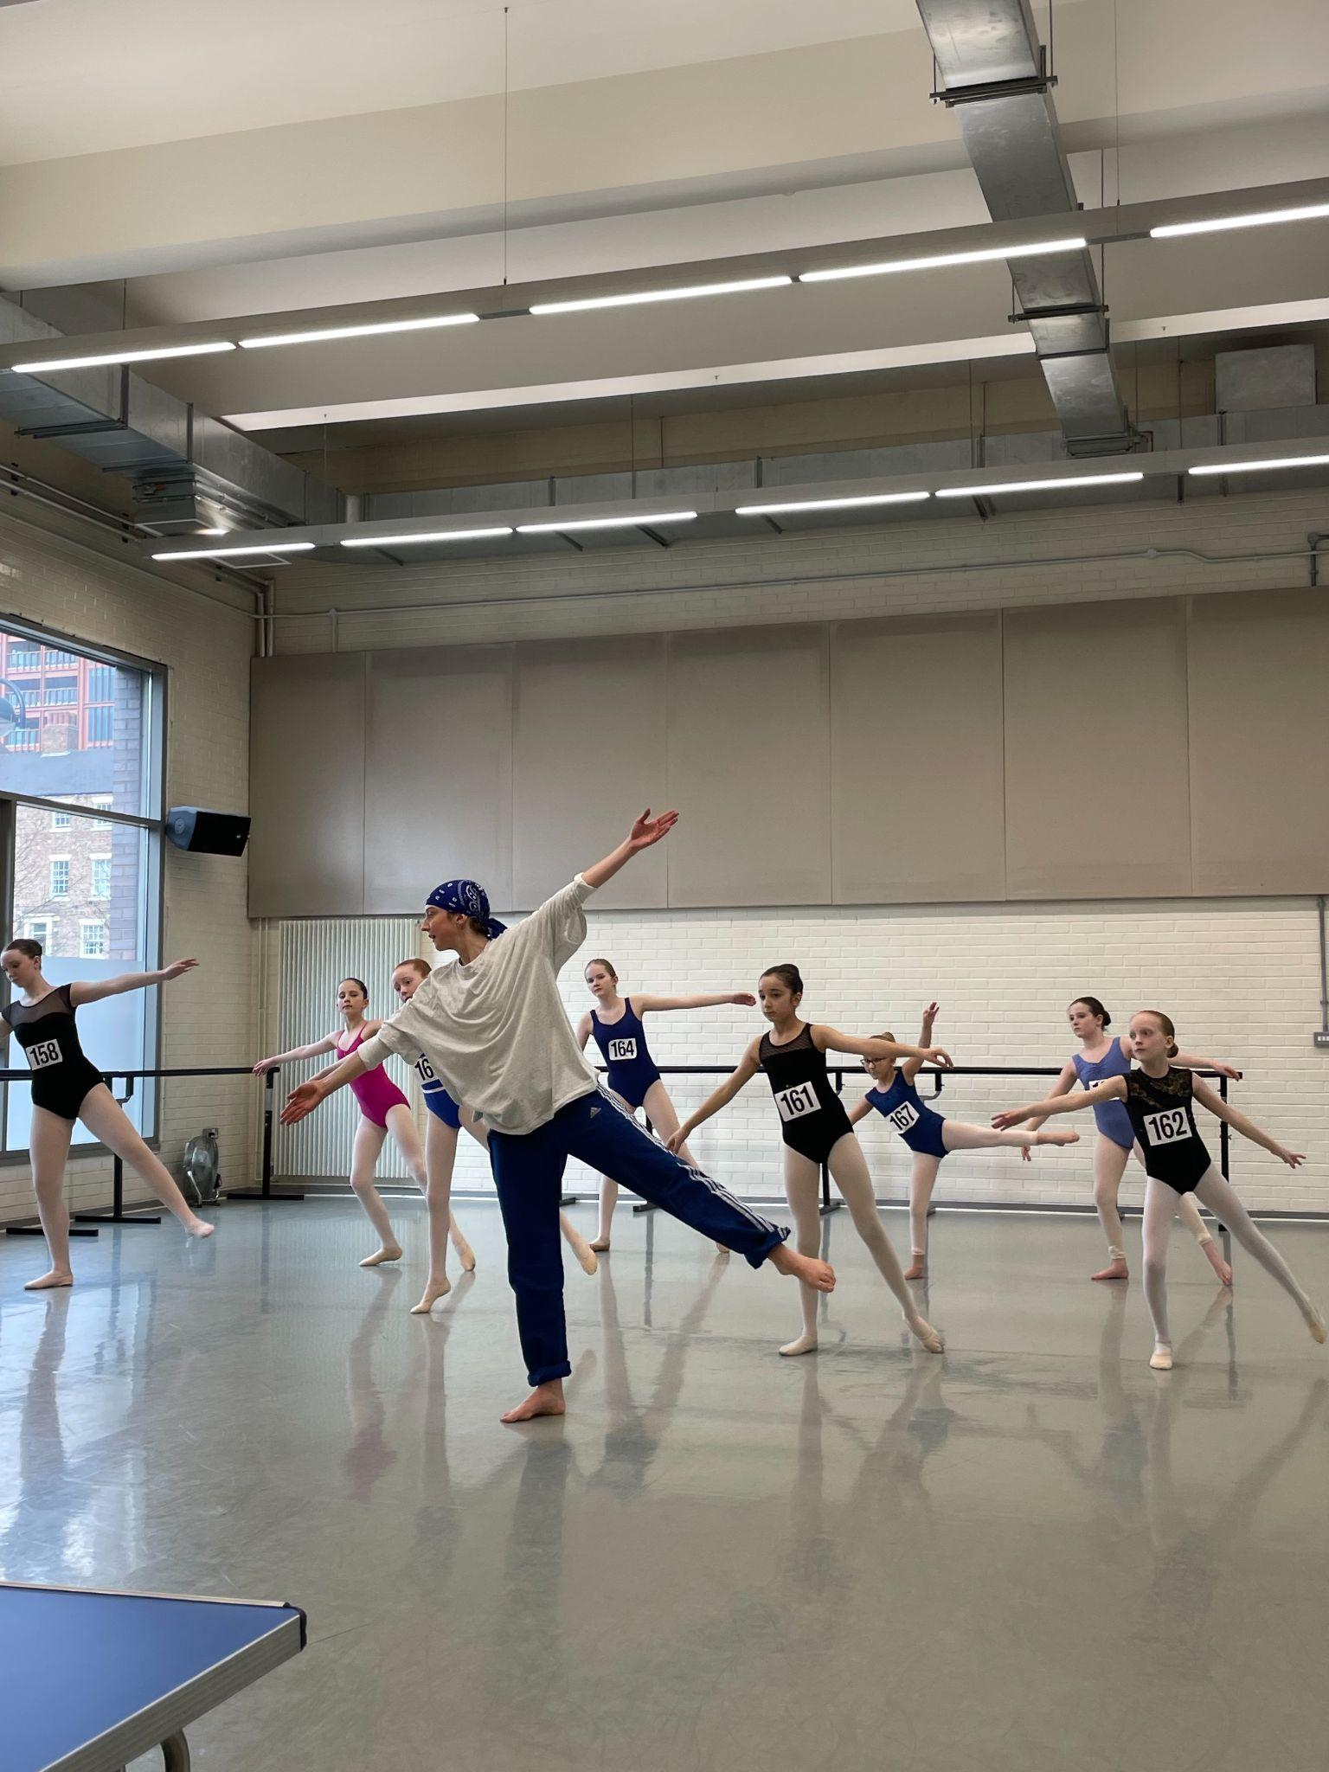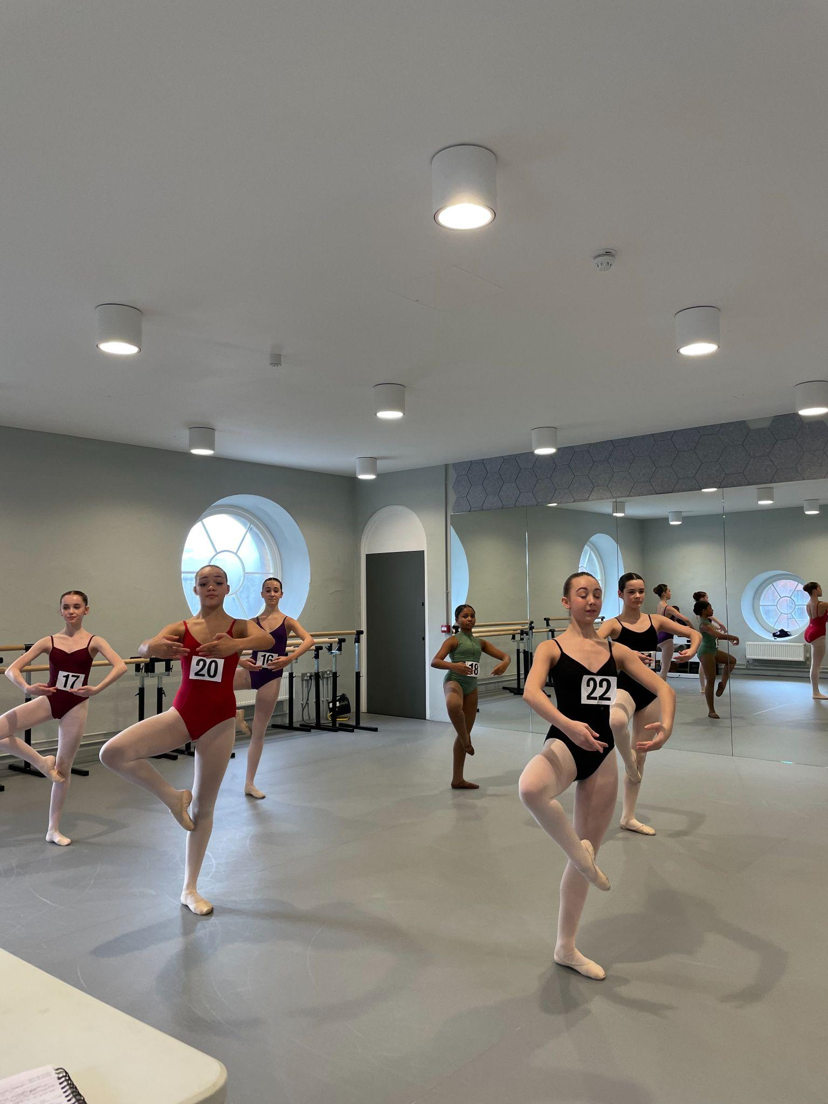

| * **How many auditions will there be?** |  |
| --- | --- |
| * There will be one round of auditions |  |
| * **If I was part of the 2024 performance company do I re-audition?** |  |
| * Yes, you will need to re-audition for the 2025 company |  |
| * **Can I audition online?** |  |
| * Yes, we have an online audition |  |
| * Dancers who attend the zoom audition will also need to film themselves |  |

**What happens at the audition?**

| * You will sign in at the main entrance |  |
| --- | --- |
| * Arrive dressed ready to dance |  |
| * Arrive with your hair ready for ballet |  |
| * You will be given an audition number |  |
| * You will be given safety pins to secure the number |  |
| * You cannot leave the building until the audition class is finished |  |
| * Please make sure you have enough water |  |
| * Please make sure you have nut-free snacks. |  |

**What do I need to bring to the audition?**

| * A water bottle (can be refilled if needed) |  |
| --- | --- |
| * Dancewear- Leotard/Tights/Socks/Skirt/Shorts (all items must be clearly named) |  |
| * Warm up clothes |  |
| * Flat ballet shoes |  |
| * Pointe shoes (if already working en pointe) |  |
| * Named Bag suitable for carrying dance-wear |  |

**What should I not bring?**

| * **Please do not bring nuts, or products containing nuts.** |  |
| --- | --- |

**Can I bring a mobile phone to the audition?**

| * Mobile phones must not be used in the studio |  |
| --- | --- |
| * You can take photographs for your memories |  |
| * But please take photos outside of the building |  |

**I am a part of London Children’s Ballet Main Company.**

**When should I audition?**

| * Sunday 23 February 2025 |  |
| --- | --- |

**If I was 18 in 2024 will I be able to take part in 2025?**

| * The maximum age for the 2025 season is 18. |  |
| --- | --- |
| * Please contact us directly if you have a disability and are over the age of 18 | **18+** |

**Can I pay in installments?**

| * The audition fee must be paid in one go. |  |
| --- | --- |
| * It is possible to pay the fee for the residential in three installments. |  |
| * Further details will be published to successful applicants. |  |

**I can no longer attend the audition, will I receive a refund?**

| * Audition fees are not refundable. |  |
| --- | --- |
| * We will try to give you a different date. |  |

**Will the auditions be filmed?**

| * All auditions will be filmed/photographed for internal use only. |  |
| --- | --- |
| * If you have any questions please email [admin@nationalyouthballet.org](mailto:admin@nationalyouthballet.org) |  |