National Youth Ballet - Arts for Impact Easy Read

About Arts for Impact:

Arts for Impact is run by The Big Give | 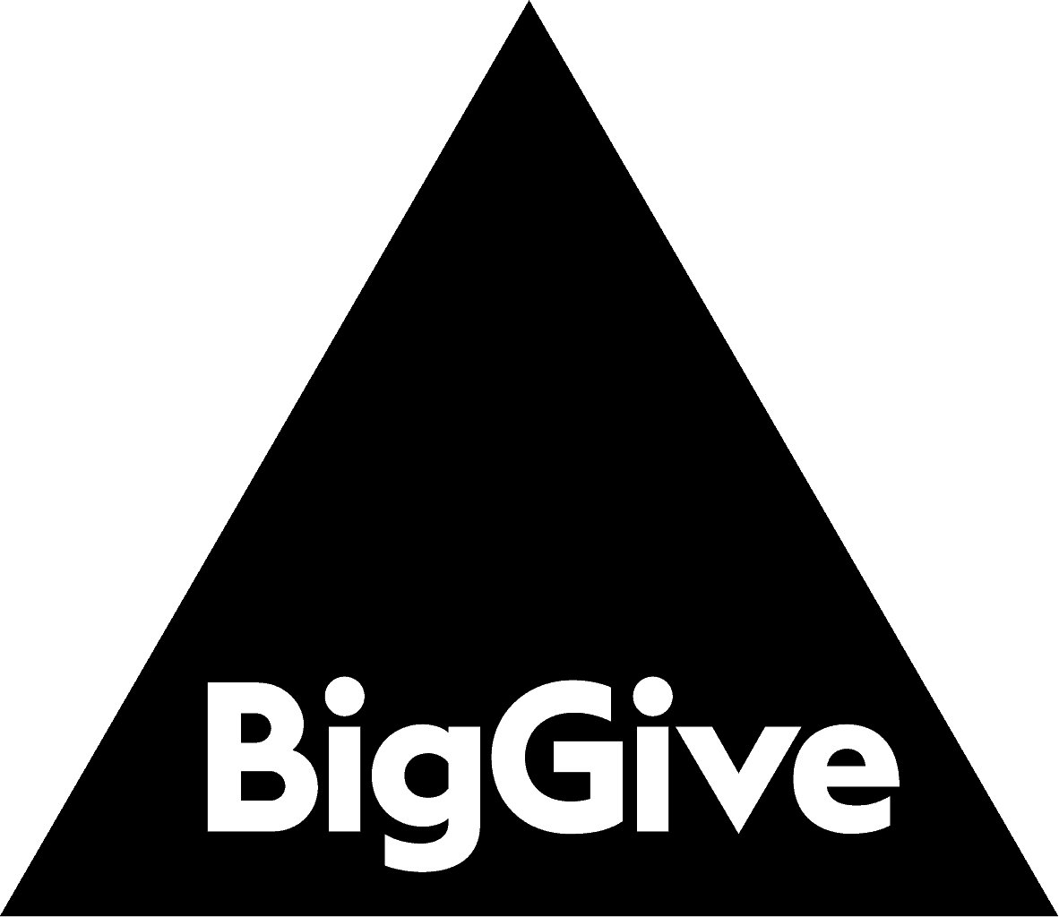
It is an online funding campaign | 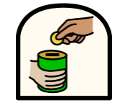
The campaign runs from Tuesday 18th March to Tuesday 25th March | 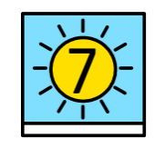
It supports Arts and Culture Charities | 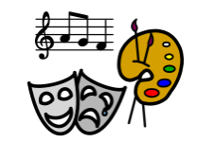
During the campaign any public donation made is doubled by a funding partner | 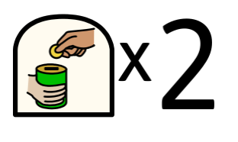
This means if you donated £1 to a charity, they would receive £2 | 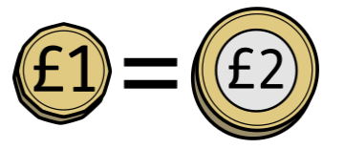
National Youth Ballet is taking part in the campaign. | 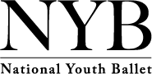

About National Youth Ballet’s Campaign:

National Youth Ballet wants to bring ballet to more young dancers | 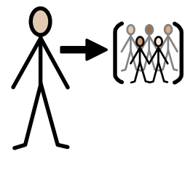
This includes making all our work inclusive | 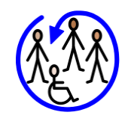
Creating a new dance project in the Midlands | 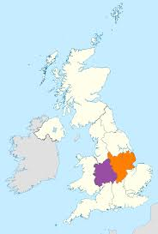
And a new partnership with OnSide Youth Zones | 
We want to raise £10,000 to help make this work happen | 
We will be asking for donations during the Arts for Impact Campaign | 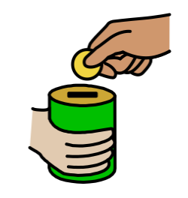
During the campaign the donations we receive will be doubled until we reach our £10,000 target
You can donate from Tuesday 18th March | 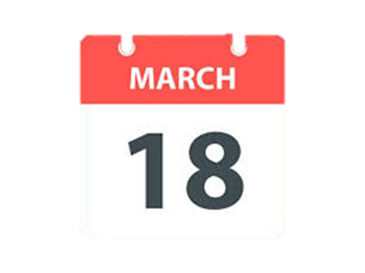
We will share a link to donate on our website | 
And on our social media | 
You can also help by sharing our campaign | 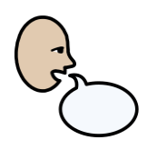
You can share our website page | 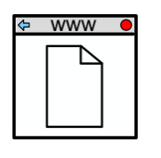
And you can share our social media posts | 
If you’ve got any questions, you can contact our Fundraising Manager, Martha, by email: martha@nationalyouthballet.org | 

