NYB 2026 Auditions
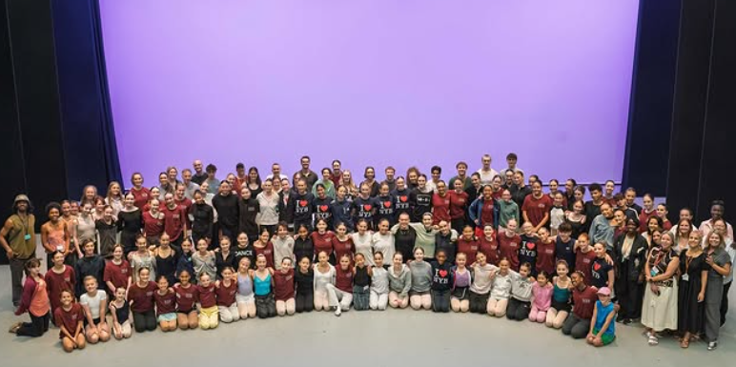 | Auditions are open for our two inspiring summer courses:  - the Residential Performance Company  - the Residential Performance Company Intensive
 | The courses help you to be creative
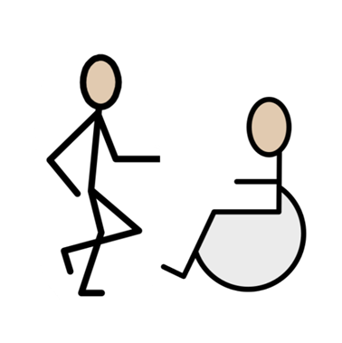 | The courses help you collaborate with other dancers
 | The courses give you performance opportunities

How to apply
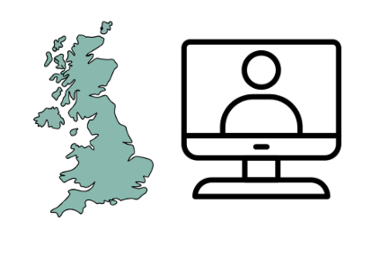 | Auditions will take place across the UK and online
 | Auditions cost £50
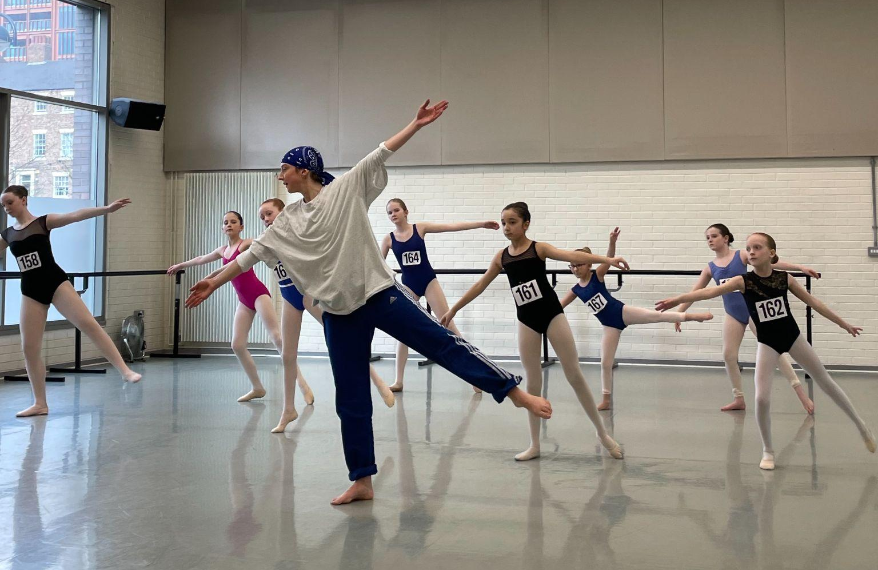 | If you wish to be considered for either the Residential Performance Company and/or the Residential Performance Company Intensive you must attend an audition.
 | Audition places are booked on a first come first served basis
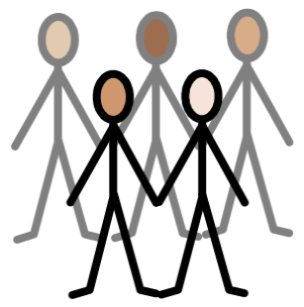 | Each class has a maximum capacity of 25 dancers

What does an audition include?
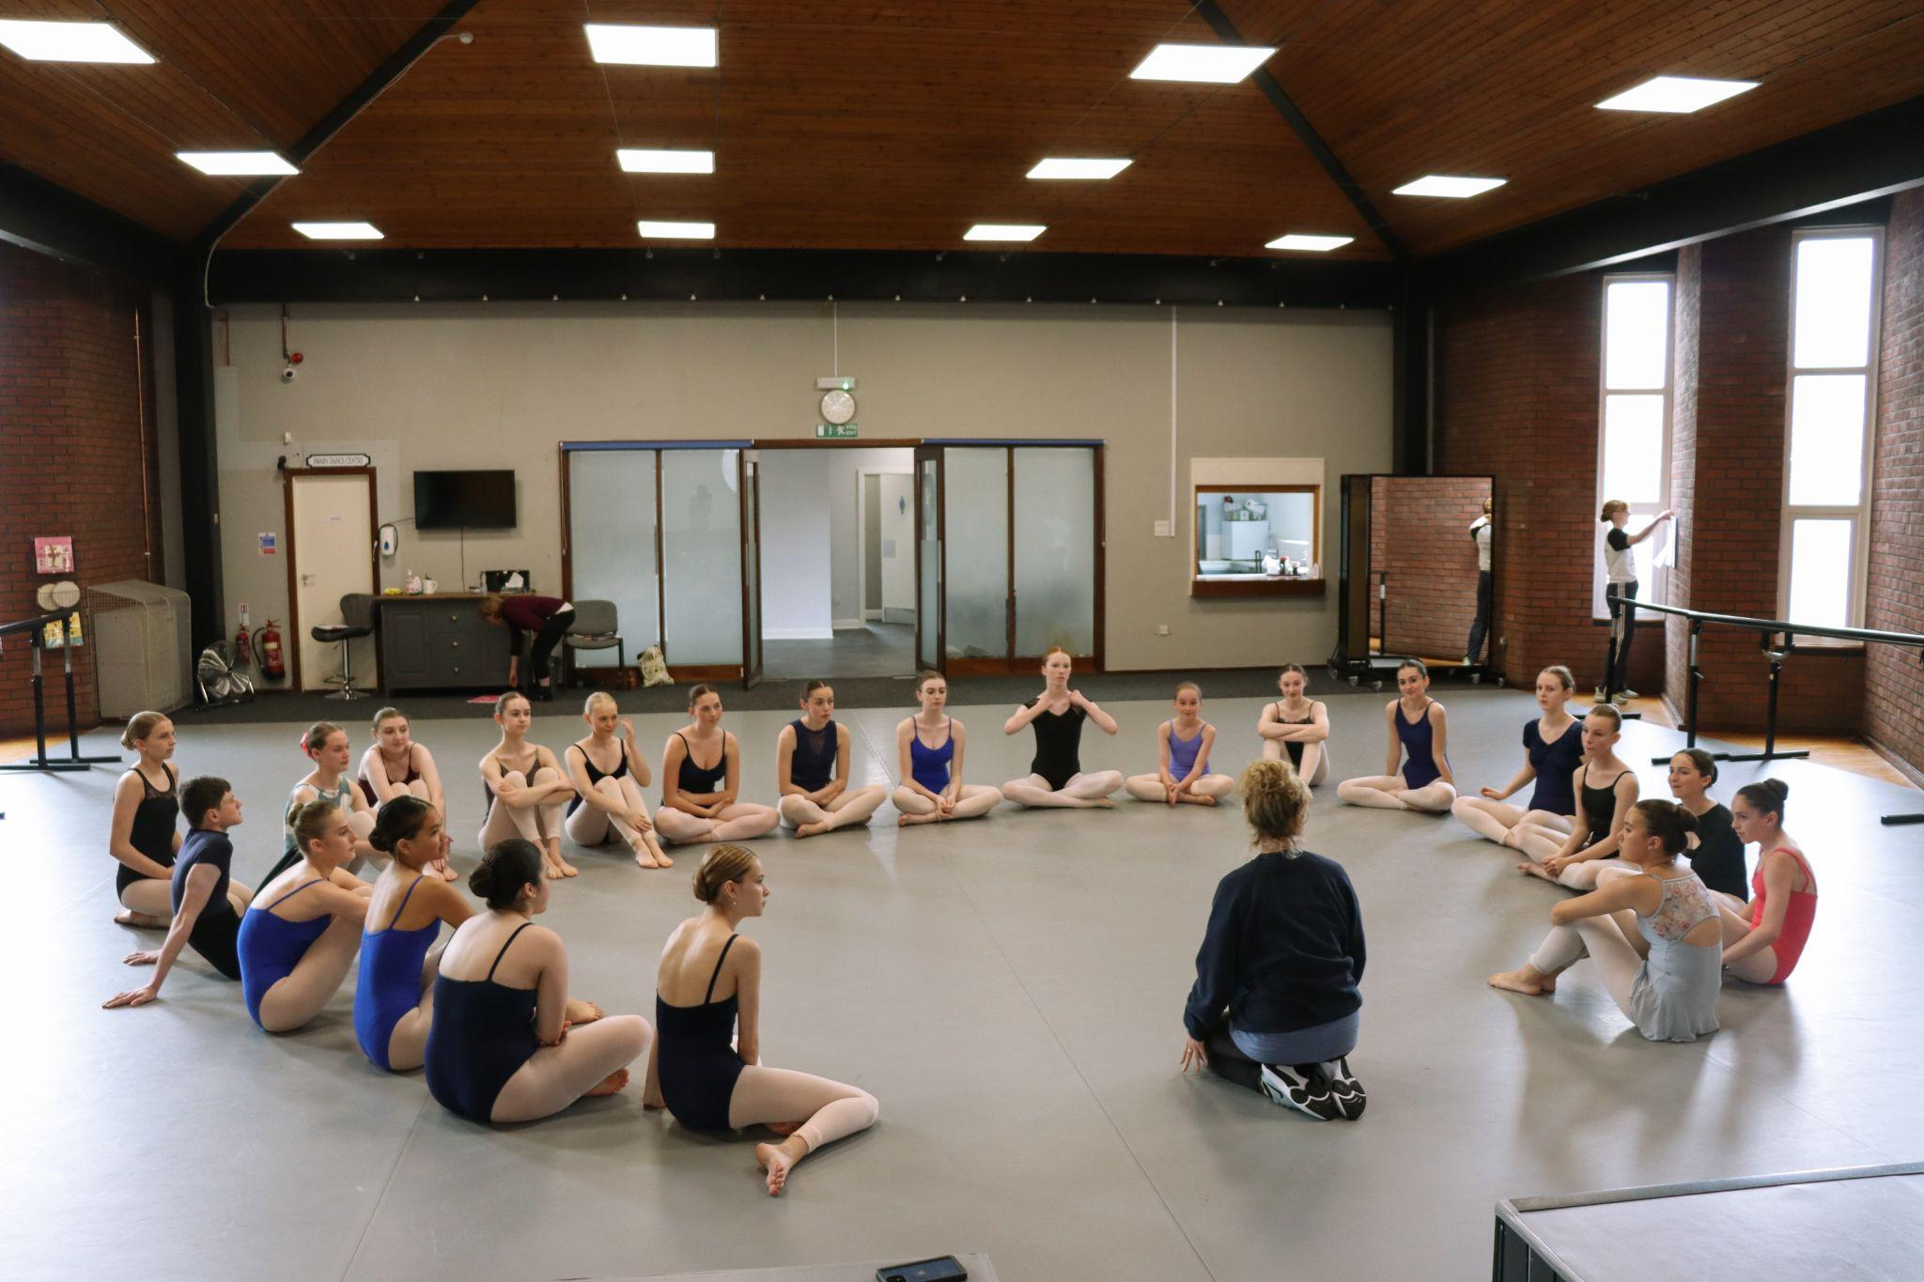 | Time to settle in and relaxation with a Moving Minds session
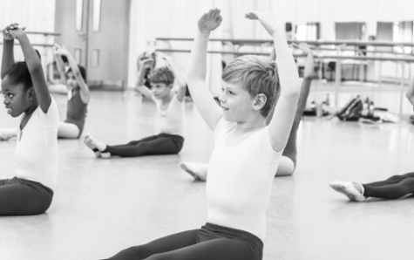 | A ballet class
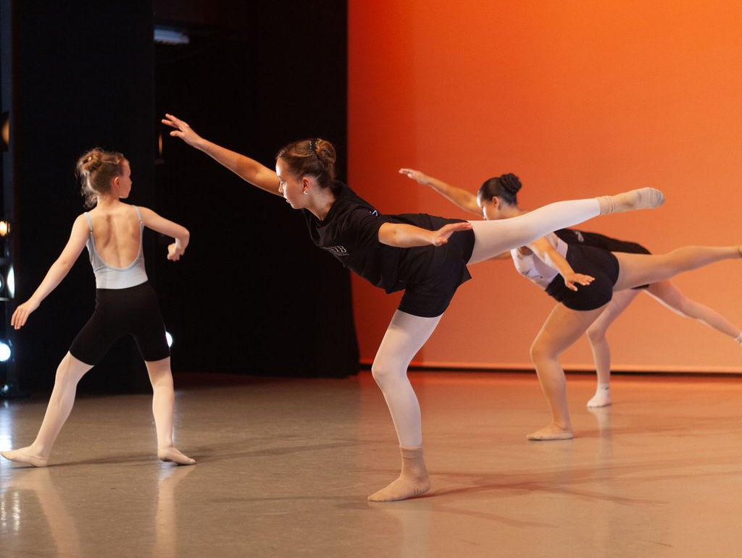 | A contemporary class
 | Those who audition via zoom will need to upload a recording of three sections of the audition
 | This can be recorded on a phone or similar device and does not need to be professionally recorded
 | All auditions will be filmed for NYB use only

How to book
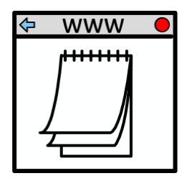 | Dates, locations and booking links are all available on the NYB website
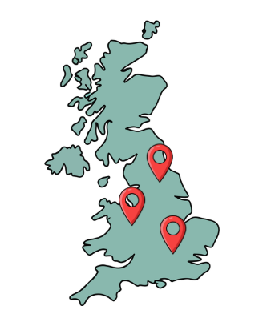 | In the event that the audition for your age group is sold out, please attend an audition at an alternative location where possible.
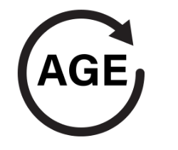 | If another location is not possible for you, please book into the closest age group at the venue you wish to attend and contact us at admin@nationalyouthballet.org.
 | For those taking part in London Children’s Ballet please book onto the audition on Sunday 22 February 2026
 | You can find Frequently Asked Questions on the NYB website

Support and Access
 | If you need any support with completing an application form please contact us at admin@nationalyouthballet.org.
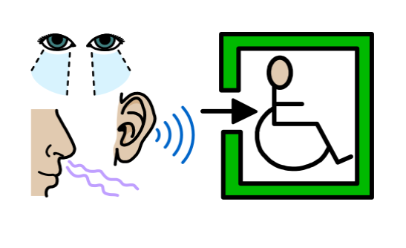 | There is a space for you to share your additional access needs within our form
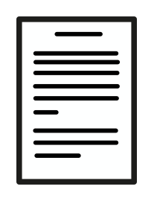 | We welcome any access riders via the email address above

