NYB Audition FAQs 2026

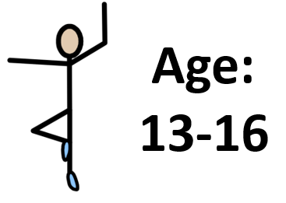 | Question: I’m aged 13-16. Can I audition for both programmes at the same time?
 | Answer: Yes. You can let us know your first choice on the application form.

? | Question: What are the different 2026 residential programmes?
3 | Answer: There are 3 different programmes.
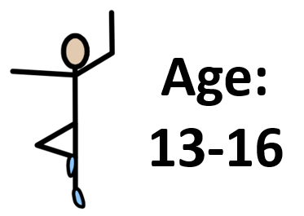  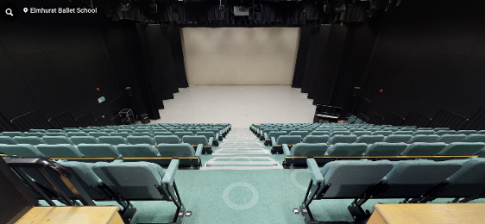 | 1. Residential Performance Company Intensive. This is a 3-day (2-night) residential at Elmhurst Ballet School for dancers aged 13-16 finishing  with an end of course sharing in Elmhurst’s Studio Theatre.
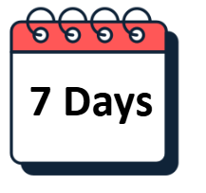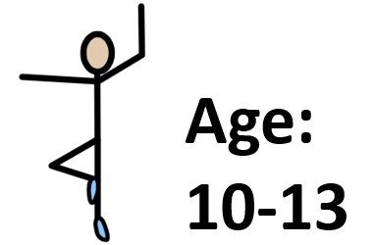  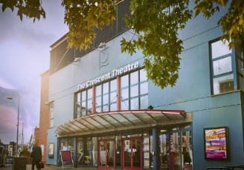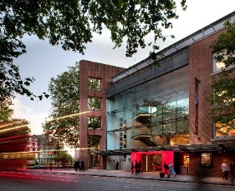 | 2. Residential Performance Company. This is a 7-day (6 night) residential at Elmhurst Ballet School for dancers aged 10-13 where dancers will perform at the Crescent Theatre in Birmingham and Sadler’s Wells in London.
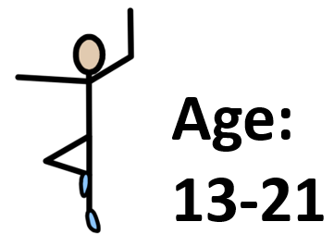 | 3. Senior Residential Performance Company.  This is a 9-day (8 night) programme at Elmhurst Ballet School for dancers aged 13-19 (21 for d/Deaf and disabled dancers) where dancers will perform at the Crescent Theatre in Birmingham and Sadler’s Wells in London.

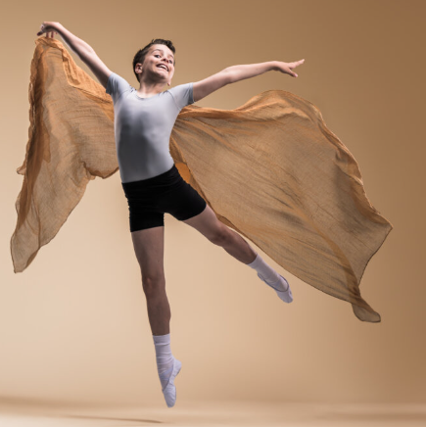 | Question: If I was part of the 2025 performance company will I have to re-audition to be a part of the performance company in 2026?
 | Answer: Yes, you will need to re-audition

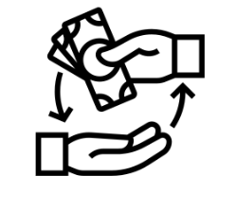 | Question: Will I get a refund if I am unable to attend the audition?
 | Answer: No, audition fees are non-refundable.
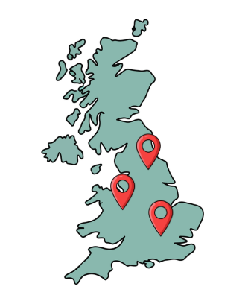 | We will try, wherever possible, to accommodate you either at another face-to-face audition or at the online audition.

Question: Can I audition online?
Answer: Yes, we have an online audition option for those who are unable to attend in person.

 | Question: Will auditions be filmed?
 | Answer: Yes, all auditions will be filmed/photographed for internal use only.

 | Question: What happens at the audition registration?
 | Registrations will take place in the main foyer of the venue
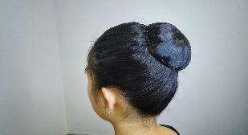  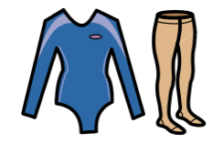 | You should come ready to dance with appropriate clothing over your dance-wear and your hair  ready for ballet class
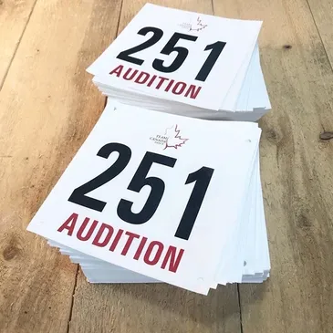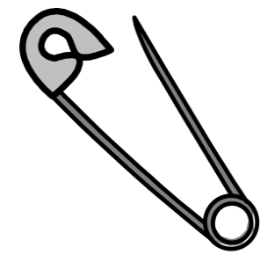 | You will be given an audition number and safety pins to secure the number
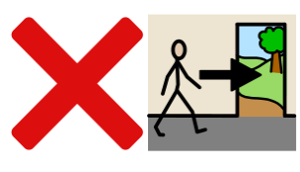 | Students will not be permitted to leave the building until their audition class is finished
   | Make sure you have enough water and nut-free snacks to keep you going before and after class.

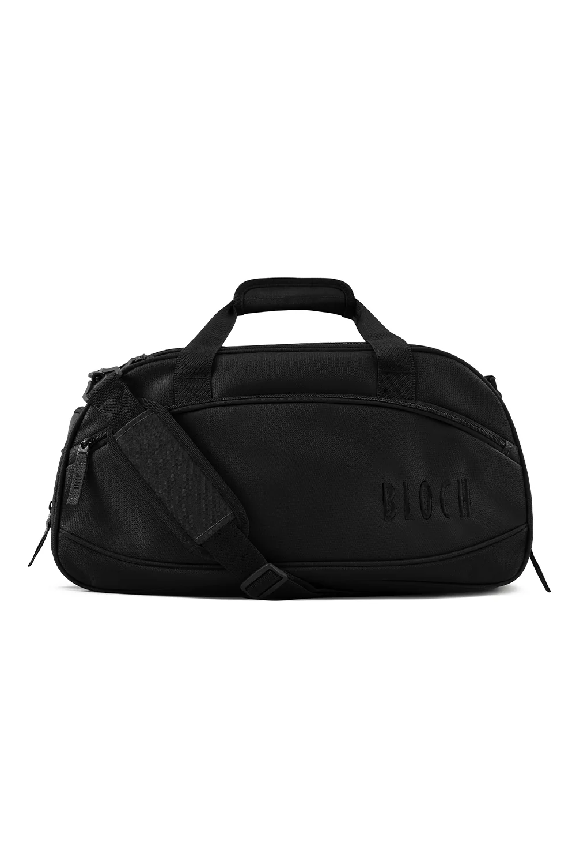 | Question: What do I need to bring to the audition?
 | A water bottle (can be refilled if needed)
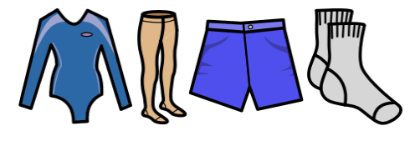 | Dancewear- Leotard/Tights/Socks/Skirt/Shorts (all items must be clearly named)
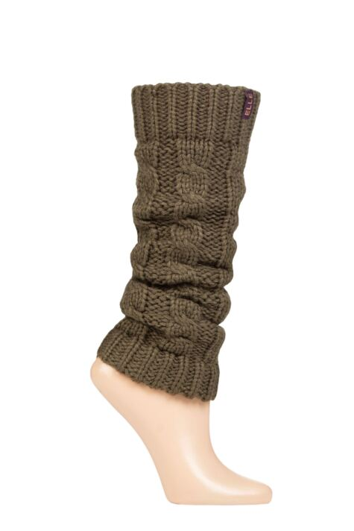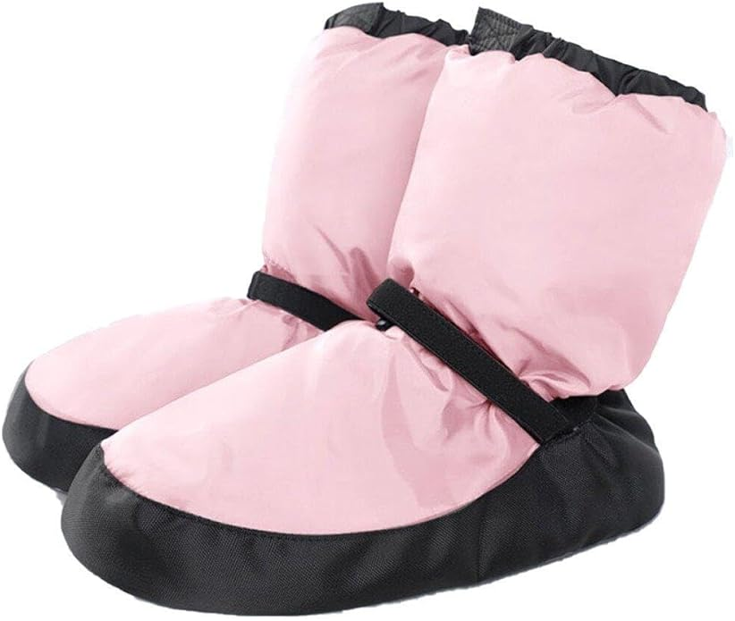 | Warm Up Clothes
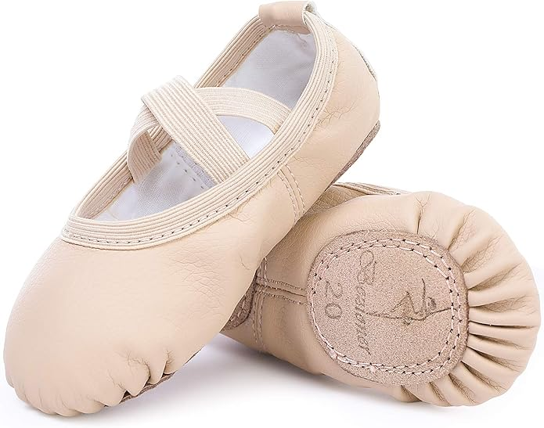 | Flat ballet shoes
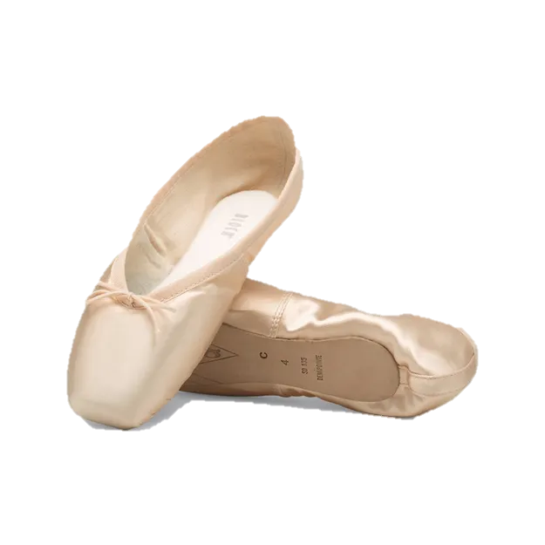 | Pointe shoes (if already working en pointe)
 | Named Bag suitable for carrying dance-wear, shoes, etc. to classes

 | Question: What should I not bring?
 | Answer: Please do not bring nuts, or products containing nuts.

 | Question: Can I bring a mobile phone to the audition?
 | Answer: Yes but mobile phones must not be used in the audition or audition studio.
 | You can take photographs for your memories
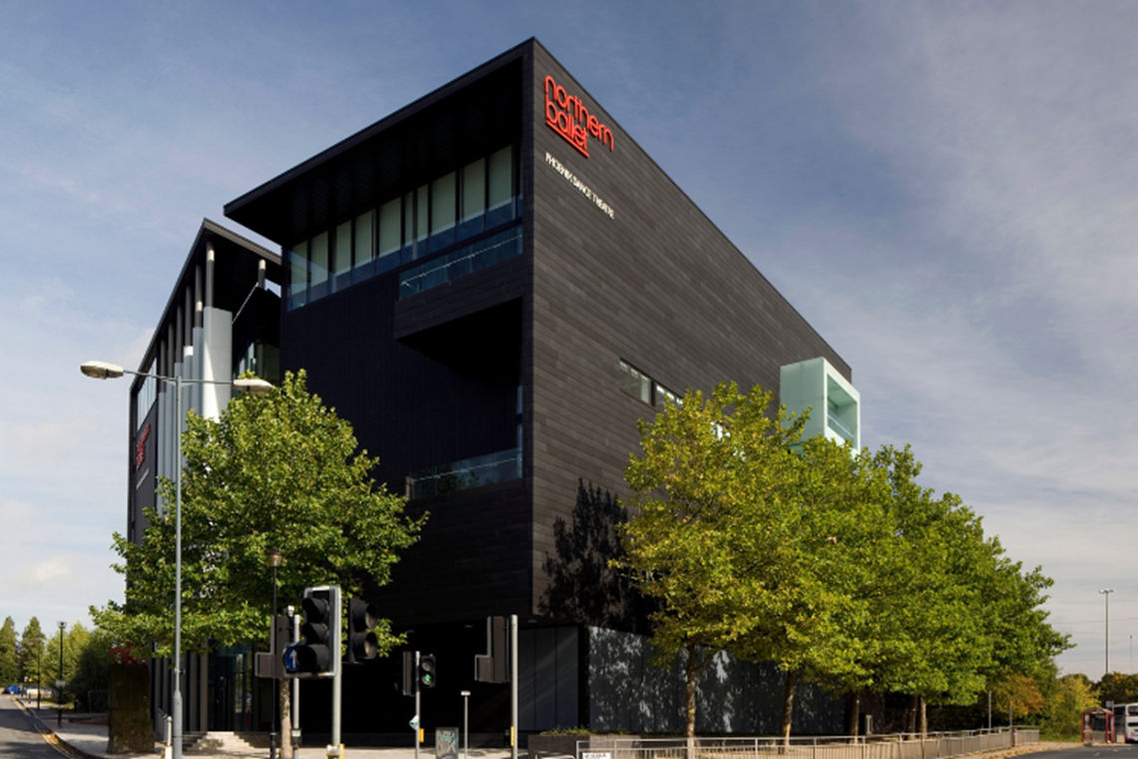 | But please take photos outside of the building

Question: I am a part of London Children’s Ballet.

When should I audition?

 | Answer: 22nd February

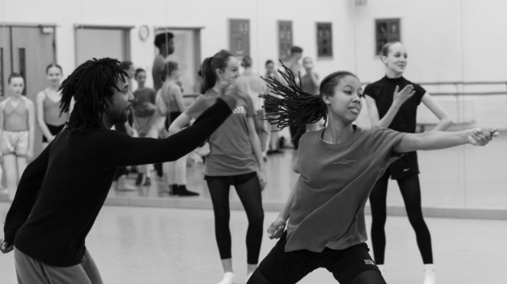 | Question: Will the same choreographers be working on the 2025 and 2026 performance seasons?
 | Answer: Yes, it will be the same choreographers

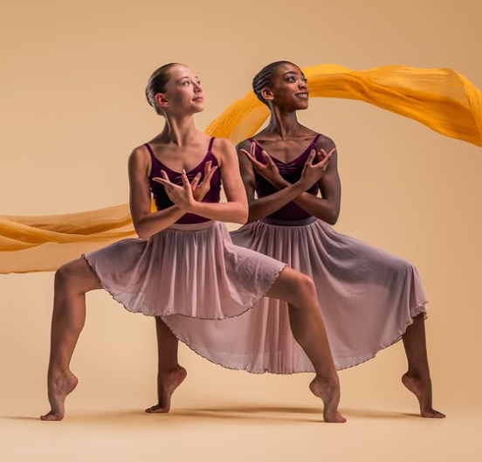 | Question: Will we be performing the 2025 content in 2026?
 | Answer: The 2025 creative team will return in 2026 and will develop their pieces based on ideas they explored in 2025.

18+ | Question: If I was 18 in 2025 will I be able to take part in 2026?
 | Answer: Yes, in 2026 we will be accepting applications from those students who are aged 19 at the time of the 2026 performance (5 September 2026).

 | Question: Can I pay in instalments?
 | The audition fee must be paid in one go.
 | It is possible to pay the fee for the residential in three instalments.
 | Further details will be published to successful applicants.

