Residential Performance Activities
 | NYB has been delivering work for almost 40 years.
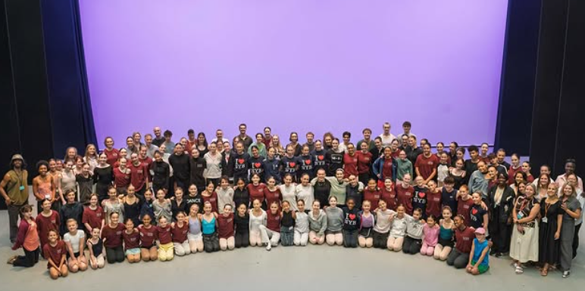 | Our Residential Performance Activities aim to inspire the next generation of dancers.
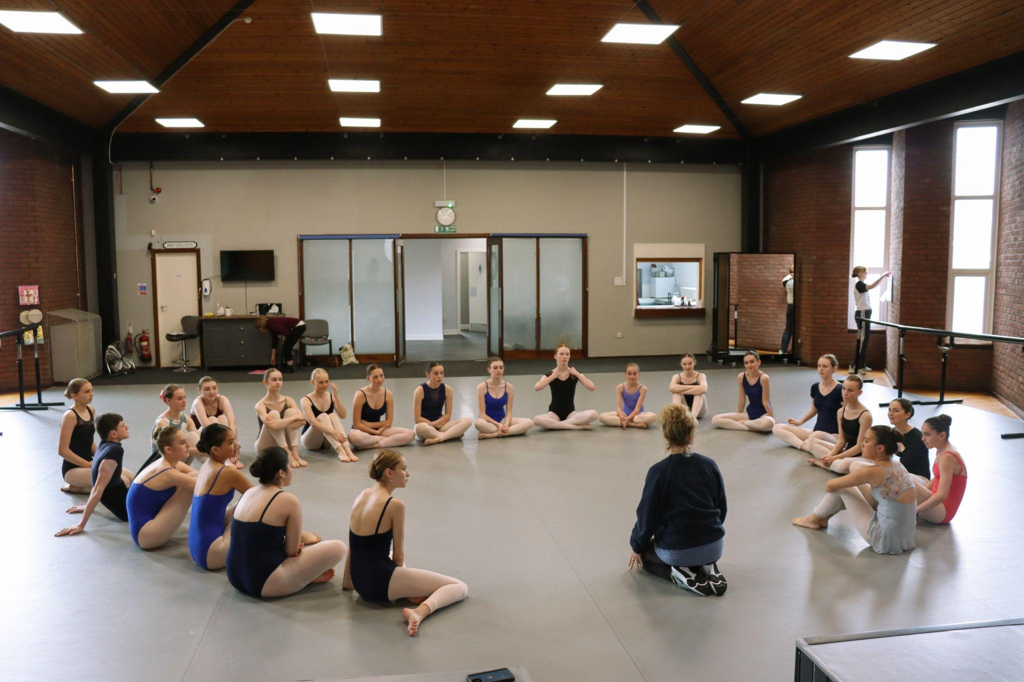 | They aim to replicate what life is like in a professional ballet company.
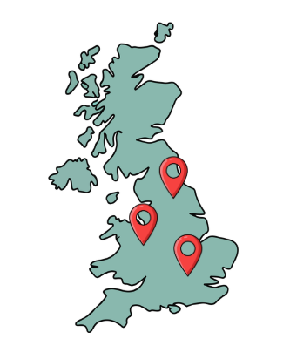 | The residences bring together young people from across the UK.
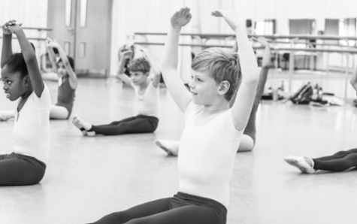 | Participants take part in daily class and rehearsals.
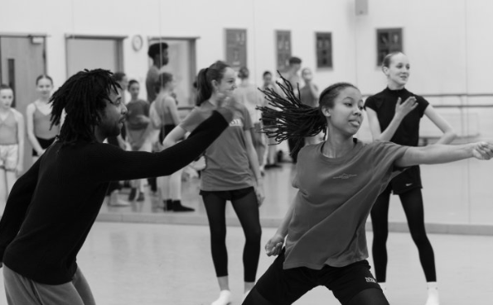 | Participants take part in workshops with renowned teachers and choreographers.
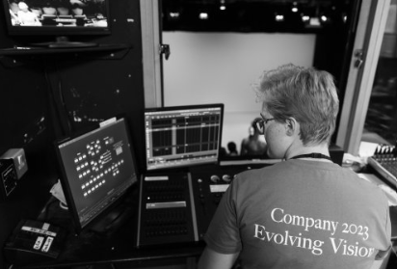 | Participants also work with professional lighting, wardrobe, make-up, and technical teams.
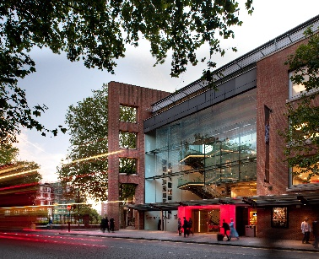 | Each residential ends with performances at places like Elmhurst Ballet School and Sadler’s Wells Theatre.
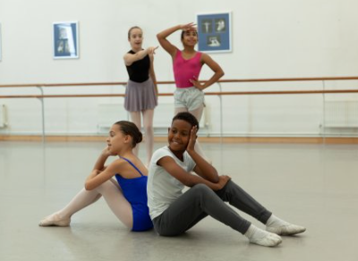 | Participants can also develop their creativity by taking part in a Choreographic Showcase.
   | Participants develop performance skills, creativity and lifelong relationships.
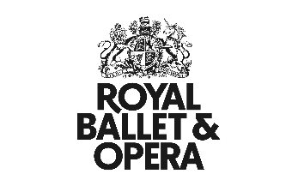  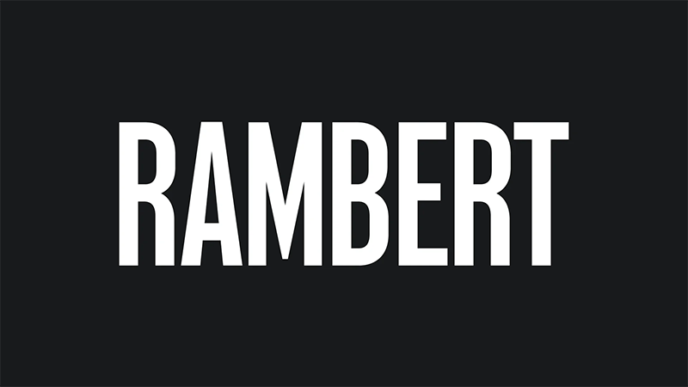 | Our alumni have gone on to join major companies including The Royal Ballet, Birmingham Royal Ballet, English National Ballet, Northern Ballet, Scottish Ballet, Rambert, and Matthew Bourne’s New Adventures.
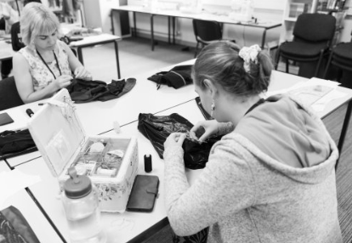 | Others develop successful careers in the creative industries.
 | Visit our other webpages to find out about auditioning for our 2026 season.

