National Youth Ballet’s Summer Courses auditions are now open!

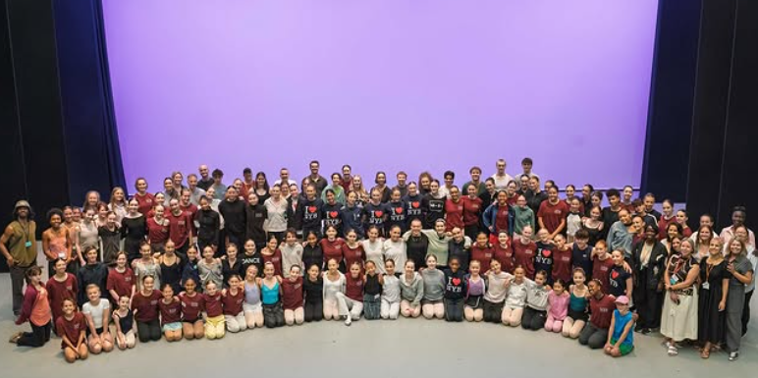 | Auditions are open for our two inspiring summer courses:  - the Residential Performance Company  - the Residential Performance Company Intensive
 | The courses help you to be creative
 | The courses help you collaborate with other dancers
 | The courses give you performance opportunities

Residential Performance Company
 | The Residential Performance Company is a full-scale performance opportunity
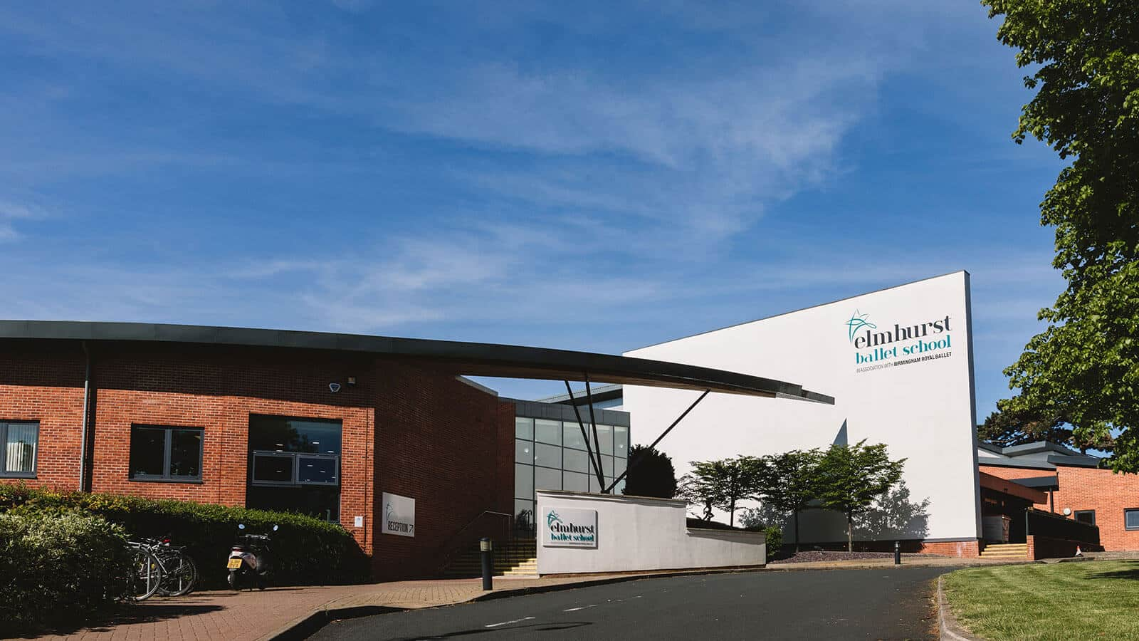 | You will take part in intensive rehearsals at Elmhurst Ballet School
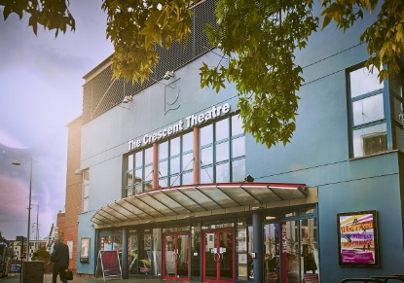  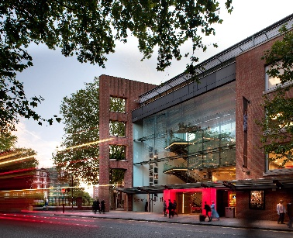 | And then perform at Birmingham’s Crescent Theatre and London’s Sadler’s Wells Theatre
  Age: 10-21 | Open to dancers aged 10-19 (we welcome d/Deaf or disabled dancers from 10-21)
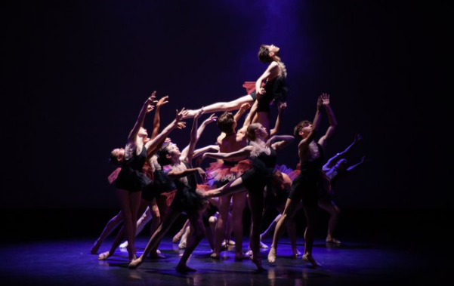 | Dancers will have good technique and artistry
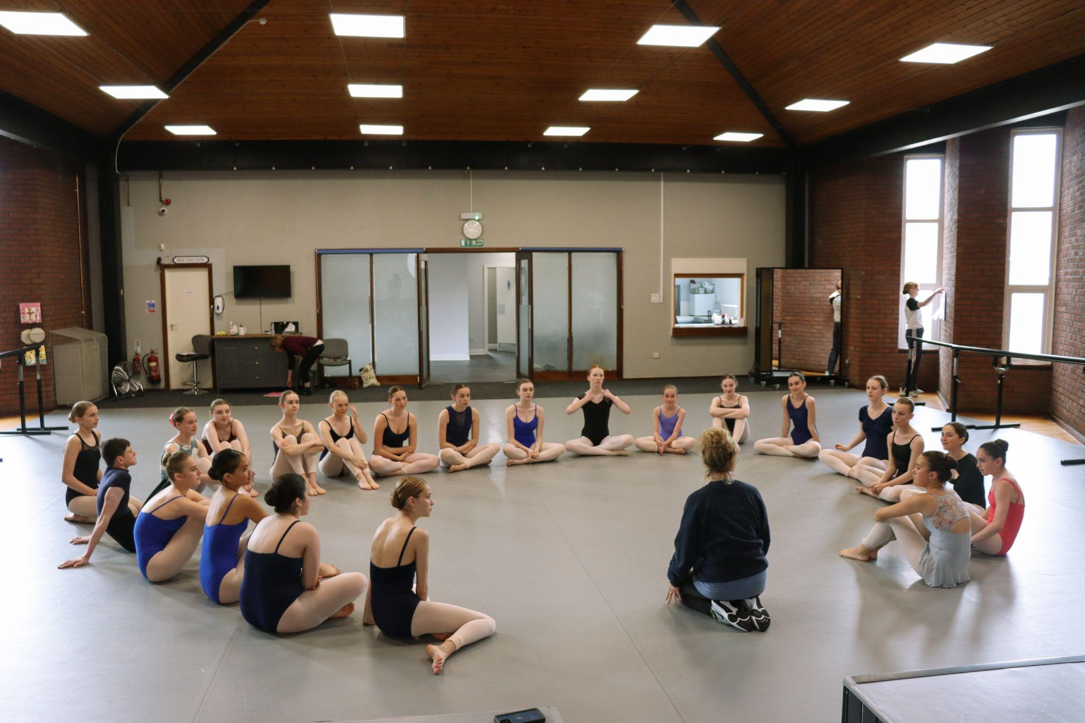 | Dancers will experience what life is like in a professional ballet company
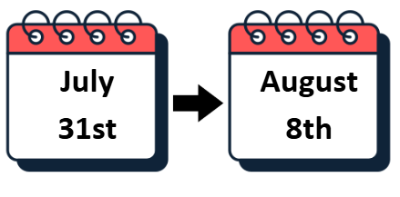 | The residential dates at Elmhurst are:  Friday 31st July – Saturday 8th August 2026  (10-13 year olds to attend Sunday 2nd August – Saturday 8th August 2026)
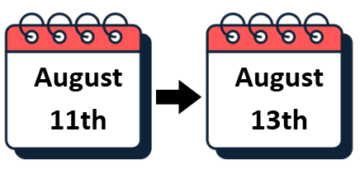 | Rehearsals and Performances at the Crescent Theatre, Birmingham will take place:  Tuesday 11th August – Thursday 13th August 2026
 | The gala performance at Sadler’s Wells Theatre, London will take place:  Saturday 5th September 2026

Residential Performance Company Intensive
 | The Residential Performance Company Intensive is a shorter, high-impact course for 20 dancers
 | The course is for dancers who want to challenge themselves
 | It will help build confidence
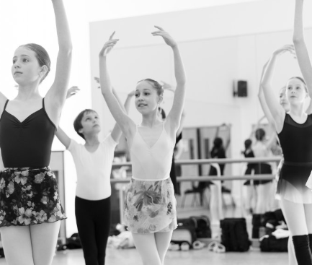 | It will help develop technique and artistry
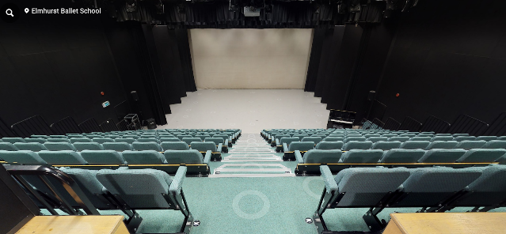 | You will take part in a performance at Elmhurst Ballet School
Age: 13-16 | The course is open to dancers aged 13-16 years
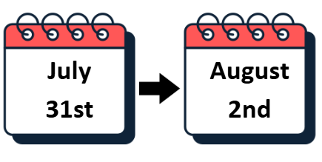 | The residential dates at Elmhurst are:  Friday 31st July – Sunday 2nd August 2026
 | The performance date at Elmhurst is Sunday 2nd August 2026

Course Fees
 | Course Fees are listed on the audition information webpages
  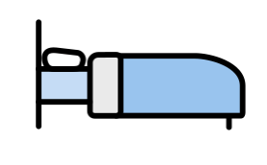  RPC or RPCI | Course fees vary depending on age, which course you’re doing and whether you are residential or non-residential
 | You can apply for a bursary to help with the cost of taking part
 | You can find out more information about bursaries on the NYB website

Support and Access
 | If you need any support with completing an application form please contact us at admin@nationalyouthballet.org.
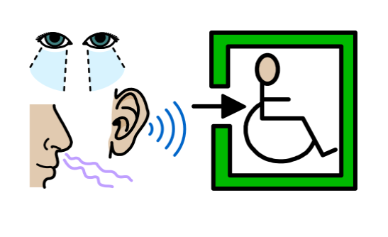 | There is a space for you to share your additional access needs within our form
 | We welcome any access riders via the email address above

