NYB 2026 Classes
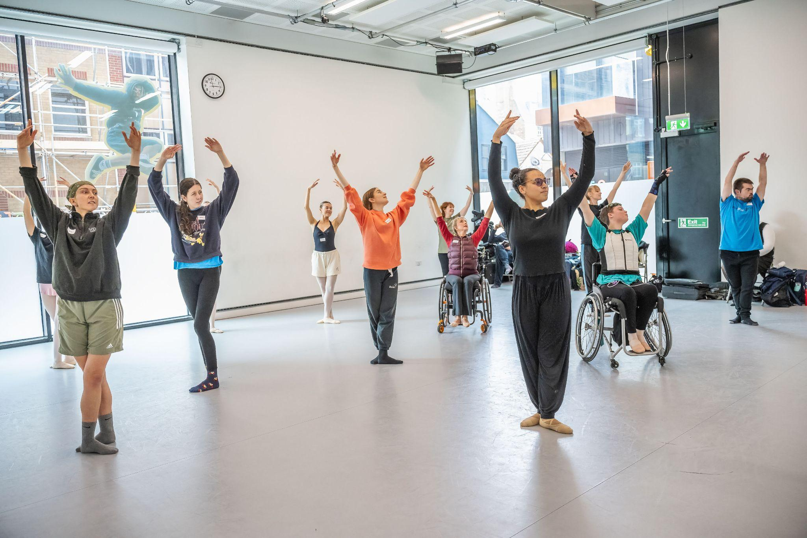 | Booking is open for our two NYB All In! Inclusive Ballet Classes
 | The class will help you to be creative
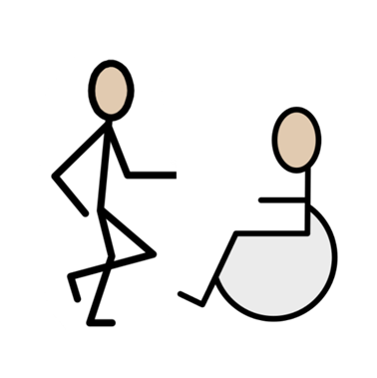 | The class will help you explore ballet in new ways

How to apply
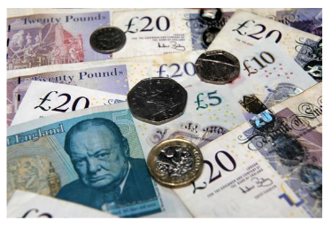 | Classes cost £8
 | Places are booked on a first come first served basis
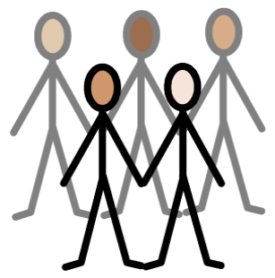 | Each class has a maximum capacity of 10 dancers

What does the class include?
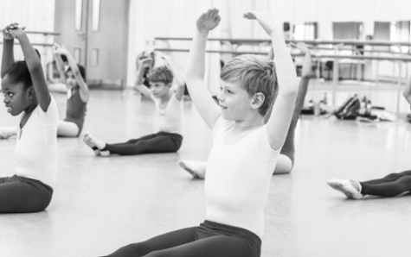 | An inclusive ballet class - designed to allow all to participate
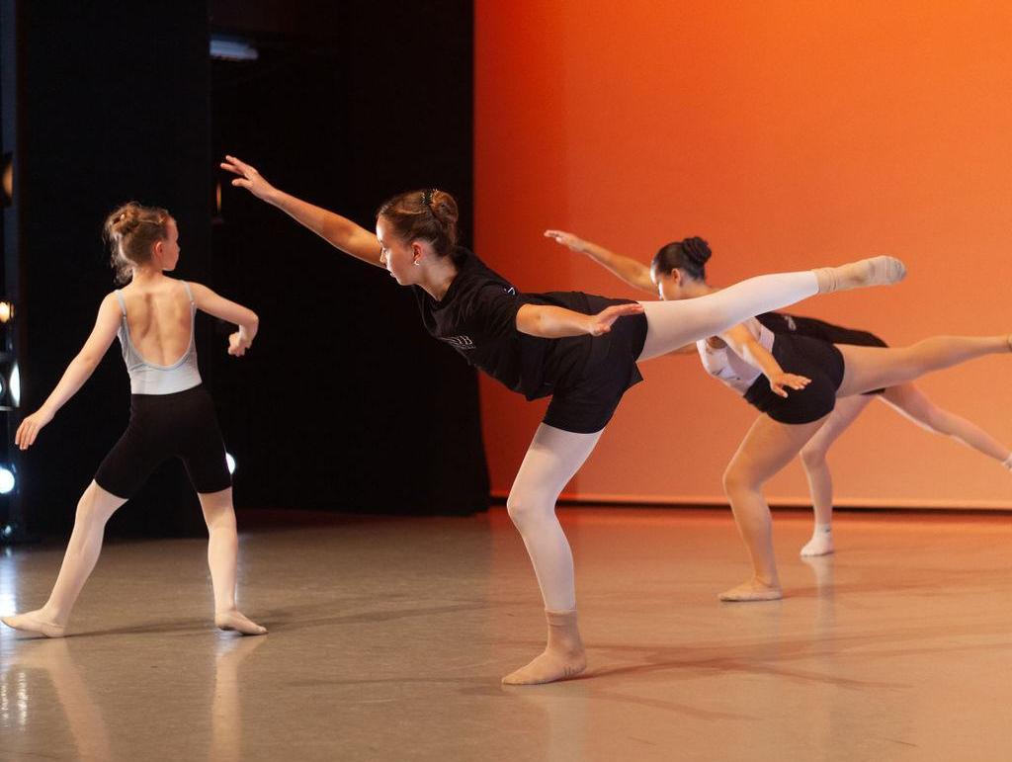 | With a chance for creative ballet responses.

How to book
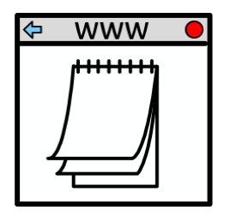 | Dates, locations and booking links are all available on the NYB website
 | If you have any questions please contact us at admin@nationalyouthballet.org.

Support and Access
 | If you need any support with completing an application form please contact us at admin@nationalyouthballet.org.
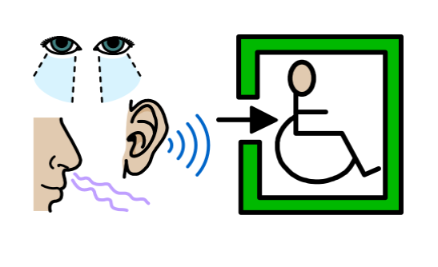 | There is a space for you to share your additional access needs within our form
 | We welcome any access riders via the email address above

