Ballet For All - Evaluation Report

- Context:

On Monday 7th July, DLG, Birmingham Royal Ballet, and National Youth Ballet hosted Ballet For All: a day of sharing, learning, and practical activity for those working with, or interested in working with, disabled dancers in ballet.

The day explored how ballet can be taught, choreographed, or facilitated in an accessible way, with a focus on practical information and tools for use in studio settings. Attendees engaged with case studies, workshops and performances from Freefall Dance Company (Birmingham Royal Ballet) and NYB All In! (National Youth Ballet), viewed examples of work, and took part in physical workshops with Freefall, NYB and Suzie Birchwood to try out inclusive approaches firsthand.

The day was facilitated by Suzie Birchwood, with guest contributions from Grace Thompson (NYB) and Lee Fisher (BRB).

- Attendees

The event attracted 41 participants, with demographic data provided by 32 attendees (78%).

Participants were predominantly from the West Midlands from the West Midlands (17) and East Midlands (5), with additional attendees from the North West, North East, South East, London and Wales. The majority identified as female (22), with male (6), non-binary (2) and genderfluid (1) participants also attending. Age ranges spanned 18-24 (6), 25-34 (11), 35-44 (11), 45-54 (1) and 55+ (2). Most participants identified as White/Caucasian (26), with representation from Mixed/Multiple ethnic groups (3), and Black, Asian and White British communities. Freelance dance artists formed the largest group (14), alongside representatives from NPO dance organisations (7), project funded organisations (2), students and recent graduates (2), and participants working in private dance schools, participatory arts, and access work. 16 participants (39%) identified as D/deaf, disabled or having a long-term health condition. Dancers from Birmingham Royal Ballet's Freefall Dance Company were also in attendance throughout the day. The company comprises 7 male and 4 female dancers, all identifying as White British, all identifying as Disabled, with ages ranging from 18-24 (2 dancers), 25-34 (3 dancers), and 35-44 (6 dancers).

- Evaluation Approach:

Ballet for All aimed to bring together artists, facilitators, dancers and professionals working in the ballet industry to share learnings and practice, reflect on current barriers, challenges and opportunities in ballet and think about what a more inclusive ballet sector could look like.

The event looked to gather two main groups of data: 1) evaluation about the event itself, including why people attended, what they thought about the day’s organisation, whether it had made them think differently about ballet and whether they would come to something similar again; 2) reflections, questions and ideas from attendees about current barriers to inclusivity in ballet and what they want the future of dance to look like.

To ensure our approach appealed and was suitable for a wide range of access and communication needs, we used a variety of methods including emoji-based postcards, questions with sticky dots, wishing trees and collage (see the Appendices for further information). Evaluation was gathered throughout the day: on entry, to understand what people thought of the event; at breaks and lunchtimes, as people began to gather their thoughts and reflect on ideas and questions posed by the presenters; at the end of the day, reflecting on the event as a whole; and post-event, in a more formal survey.

Reflections for the second group of data were also gathered through provocation tasks set by Suzie. These included group-based tasks and individual reflection covering big questions such as: “Is the goal to add people into ballet, or to change ballet itself?”, “If access is not an add-on, how do we build ballet from the ground up?” and “Who decides what ballet looks like, and who is it for?”.

The evaluation methodology was deliberately designed to accommodate the diverse access and communication needs of participants working in inclusive ballet practice. Emoji-based postcards removed literacy barriers and allowed for quick, intuitive responses, while sticky dot voting enabled participation without requiring written responses. The wishing tree and collage activities provided creative, non-verbal ways for participants to express complex ideas about ballet's future. Multiple data collection points throughout the day recognised that participants' thinking would evolve as they engaged with new ideas and experienced inclusive practice firsthand. The provocation tasks were structured as open-ended group discussions rather than formal presentations, creating space for collaborative thinking and ensuring that quieter voices could contribute through small group dynamics before sharing with the larger group

- Evaluation Overview:

3.1 Evaluation of the Event:

Attendees consistently praised the event itself, with all 28 respondents indicating they enjoyed the experience and would attend similar events in future. Comments about the event's organisation and commitment to inclusion and access included praise for the "inclusive environment," "well organised" structure, and "good use of verbal and visual aids," with particular appreciation for the comprehensive access considerations such as easy-read information, advance details about what to expect, use of Makaton, and BSL provision. One attendee noted: "I felt so comfortable to be myself... use of Makaton was a game changer... consideration of resources was fantastic and advanced information about what to expect was fantastic, properly anxiety reducing."

Attendees did highlight a need for improved physical conditions, with feedback pointing to issues with lighting ("the dark room & light"), spatial constraints ("lack of space in dance area"), and requests for smaller group activities and clearer guidance on appropriate clothing.

The task asking attendees why they came to the event also revealed interesting insight about what events like Ballet for All might look to achieve in future. The most popular motivations were "Learn more about what others are doing" (14 dots), "To connect with others" (10 dots), and both "Get new ideas to develop my practice" and "To experience something new" (8 dots each), suggesting future events should prioritise knowledge-sharing, networking opportunities, and practical skill development.

During more practical, workshop-based moments, attendees particularly valued the "mix of practical + discussion," "exploring moving in a different way but using ballet steps as a base," and "moving with lots of different bodies but with the same intention," indicating that hands-on experiential learning was highly effective in achieving the event's inclusive objectives.

    - Response Patterns and Insights

While satisfaction with the event was overwhelmingly positive, the data reveals some nuanced patterns worth examining. The respondents who indicated 'maybe' or those who did not respond to whether the experience made them think about dance in a new way may reflect participants who already approached ballet inclusively in their practice, as supported by one comment: 'I already look at dance in an inclusive way, today helped me to view ballet differently.' This suggests the event successfully attracted practitioners at different stages of their inclusive practice journey.

The strong preference for learning about others' work (14 dots) over personal reflection on ballet relationships (7 dots) indicates future events might benefit from even more case study presentations and peer-sharing opportunities. The equal interest in practical skill development and experiencing something new (8 dots each) reinforces the value of the hands-on workshop elements that participants consistently praised.

3.2 Participant Reflection:

The multiple participant reflection tasks revealed many interesting and thought-provoking insights into problems, challenges and opportunities within ballet.

Central to discussions was the fundamental question of whether the goal should be to add people into ballet or to change ballet itself. Participants grappled with whether inviting more people into the existing system was sufficient, or whether ballet needed to transform its values alongside opening its doors. As one group reflected: "We are not changing, we are adapting, creating a more enriching style," while emphasising the importance of "making ballet fit for your body, not fit your body to ballet."

Participants identified key elements that ballet should release to become truly inclusive. There was strong consensus around letting go of the restrictive "ballet body" ideal, gender stereotypes and binaries, perfectionism, and elitist attitudes that use technical language to exclude. One participant noted: "Let go of 'look' and keep hold of how you move. Feeling and energy," while another emphasised: "Elite is not bad, elitism is." The distinction between maintaining high standards while removing exclusionary practices emerged as a critical theme.

Conversely, participants were clear about what should be preserved and valued in ballet's evolution. They wanted to retain ballet's "foundation and discipline," "prestige and glamour," and essential movement qualities, while expanding what ballet could become. New values that participants wished ballet would embrace included person-centred approaches that "acknowledge dancers are humans and not machines," collaboration with disabled professionals at high levels, and valuing "the intent of movement and charisma" over conventional appearance standards.

The vision for accessible ballet from the ground up revealed sophisticated understanding of inclusive practice. Participants outlined comprehensive approaches including environmental considerations (appropriate lighting balancing neurodivergent and visually impaired needs, fresh air, accessible flooring), communication strategies (visual cues, easy-read materials, clear signposting), and pedagogical approaches that welcome access needs into the space from day one. Significantly, participants emphasised that accessibility features like ramps communicate "we want you to be here" - making inclusion an expectation rather than an accommodation.
Throughout these reflections, participants demonstrated commitment to systemic change while respecting ballet's heritage. The aspiration for "BOTH inclusive 'Nutcrackers' AND new works - a full ballet ecology of disabled + non-disabled dancers, makers + leaders" encapsulated the community's vision for an expanded, enriched ballet sector that serves everyone.

3.3 Session Observations

Observations during the practical workshops led by Freefall (Lee Fisher), NYB (Grace Thompson) and by the day’s facilitator, Suzie Birchwood, also reveal important insights into how inclusive ballet practice can be effectively implemented and experienced.

Freefall Dance Company Session:

Lee Fisher's session with Freefall explored the company's historical roots and the core values that drive their inclusive practice. The workshop shared insights into how Birmingham Royal Ballet's Freefall programme has developed its philosophy over time and the practical evolution of their approach to inclusive ballet within a traditional ballet institution. Participants were invited to explore Makaton through dance, emphasising how a variety of communication methods can support inclusive ballet teaching.

NYB Session with Grace Thompson:

Grace Thompson's workshop took a pedagogical approach, exploring different teaching techniques to dissect and explore in a ballet adage exercise. The session broke down traditional ballet sequences into component parts, in a thoughtful, accessible way, using props, symbols and spatial clues. The session demonstrated multiple pathways to understanding and executing classical ballet movements through varied teaching approaches that can reach different learning styles and access needs.

Suzie Birchwood's Universal Design Session:

Suzie's session focused on exploring Universal Design principles within ballet teaching. Universal Design is an approach that creates products, environments, and experiences to be usable by all people from the outset, rather than designing for an 'average' user and then adding accommodations. Suzie's session demonstrated how applying these principles to ballet instruction can create more effective teaching methods for everyone. This approach demonstrated how ballet instruction could be structured to accommodate diverse access needs from the outset through practical applications of universal design theories.

Across all three practical sessions, several key themes emerged that reinforce the evaluation findings. Participants consistently responded positively to the "learn by doing" approach, with many noting that experiencing inclusive practice was more impactful than discussing it theoretically. The variety of facilitation styles across the three sessions demonstrated that there is no single "correct" way to make ballet inclusive, but rather multiple valid approaches that can coexist.

Across all three practical sessions, themes emerged that reinforce the evaluation findings. The postcard feedback specifically praised the "mix of practical + discussion" and highlighted how participants valued "exploring moving in a different way but using ballet steps as a base" and "moving with lots of different bodies but with the same intention." This aligns with participants' preference for experiential learning, as evidenced by their motivation to "experience something new" being equally important as getting "new ideas to develop my practice."

The variety of approaches across the three sessions demonstrated different ways of making ballet inclusive, reflecting the broader question participants grappled with throughout the day. As one group noted: "We are not changing, we are adapting, creating a more enriching style," while also emphasising "making ballet fit for your body, not fit your body to ballet."

The practical workshops highlighted the central question posed throughout the day about whether to "add people into ballet" or "change ballet itself." Rather than providing a definitive answer, the sessions revealed the complexity of this dilemma. Each workshop demonstrated different aspects of this tension: some approaches showed how existing ballet structures could be adapted and made more accessible (adding people in), while others revealed how inclusive practice might fundamentally transform what ballet could become (changing ballet itself). This hands-on exploration helped participants understand that the question itself may be less about choosing one approach over another, and more about finding thoughtful ways to honour ballet's heritage while expanding its possibilities.

3.4 Challenges and Limitations

Several limitations should be acknowledged in both the event design and evaluation approach. The feedback about physical environment challenges - lighting, space constraints, and group sizes - suggests that even well-intentioned inclusive events can inadvertently create barriers. The request for clothing guidance highlights how assumptions about participant knowledge can exclude newcomers to ballet.

The evaluation captured voices of those who attended and stayed for the full day but may not reflect perspectives of potential participants who felt unable to attend or those who left early. The participant demographic appeared to be primarily practitioners already committed to inclusive work, which, while creating a supportive environment, may have limited exposure to more resistant or skeptical viewpoints that exist within the broader ballet sector.

Additionally, some participants noted that 'ballet is not the same as dance,' suggesting the evaluation questions may not have fully captured the specific nature of ballet inclusion challenges versus broader dance accessibility. Future events might benefit from more ballet-specific evaluation tools and deliberate outreach to include voices from more traditional ballet institutions.

- Next Steps and Recommendations:

It was reiterated – by attendees and presenters alike – the importance of acting on the suggestions and reflections posed during the event, whether by individuals in their practice, organisations in their values and ways of working and by collective action in the industry as a whole.

There remains a question about who holds the responsibility and accountability for driving this forward and for making sure that positive change and action begin to happen. Whilst we can all take some responsibility to challenge exclusionary practices in our own work, advocate for inclusive values within our organizations, and support disabled artists and practitioners, does there need to be coordinated sector leadership and formal accountability mechanisms to see the systemic transformation that participants envisioned - moving beyond individual practice to structural change that makes inclusion the default rather than the exception? And who makes the rules for who can participate in grassroots ballet and how can the participants of the Ballet For All day start to advocate to those who make the rules?

Based on the reflections and evaluation gathered during Ballet for All, the following table suggests actions that could be taken to achieve the goal of a ballet industry that is for everyone.

Area of Focus | Action | Steps to Achieve | Rationale
Industry Leadership & Governance | Establish sector-wide accountability for inclusive practice | -Create industry standards for accessibility  -Mandate inclusion training for senior leadership  -Establish disabled-led advisory boards  -Implement inclusion metrics in funding criteria | Addresses participant question: "does there need to be [sector leadership] to see [systemic change]?" - ensures change isn't left to individual goodwill
Funding & Investment | Restructure arts funding to prioritise inclusive practice | - Ring-fence funding for disabled-led companies  -Make genuine accessibility a funding requirement  -Support inclusive programming in major venues  -Invest in accessible infrastructure development | Removes financial barriers that prevent "inclusive 'Nutcrackers' AND new works" from being viable
Public Perception & Marketing | Transform how ballet is represented and marketed to the public | - Showcase diverse bodies in mainstream marketing  -Challenge media representations of ballet  -Develop public campaigns celebrating inclusive ballet  -Partner with disability organisations for outreach | Addresses participant question about "whether the public's perception of ballet needs to change first or alongside changes in industry"
Professional Development | Create industry-wide training and career pathways | - Develop inclusive pedagogy qualifications  -Establish mentorship programmes for disabled artists  -Create cross-sector learning networks  -Mandate accessibility training for all professionals | Builds capacity across the sector and creates "career paths" for disabled artists
Infrastructure & Policy | Ensure accessibility in venue design and programming | - Update building standards for dance venues  -Require audio description and BSL provision  -Establish accessibility auditing processes  -Create venue accessibility databases or partner with existing resources to examine dance-specific venues | Ensures "new venues with greater access" become standard rather than exceptional

Appendix A - What do you want to get from today?

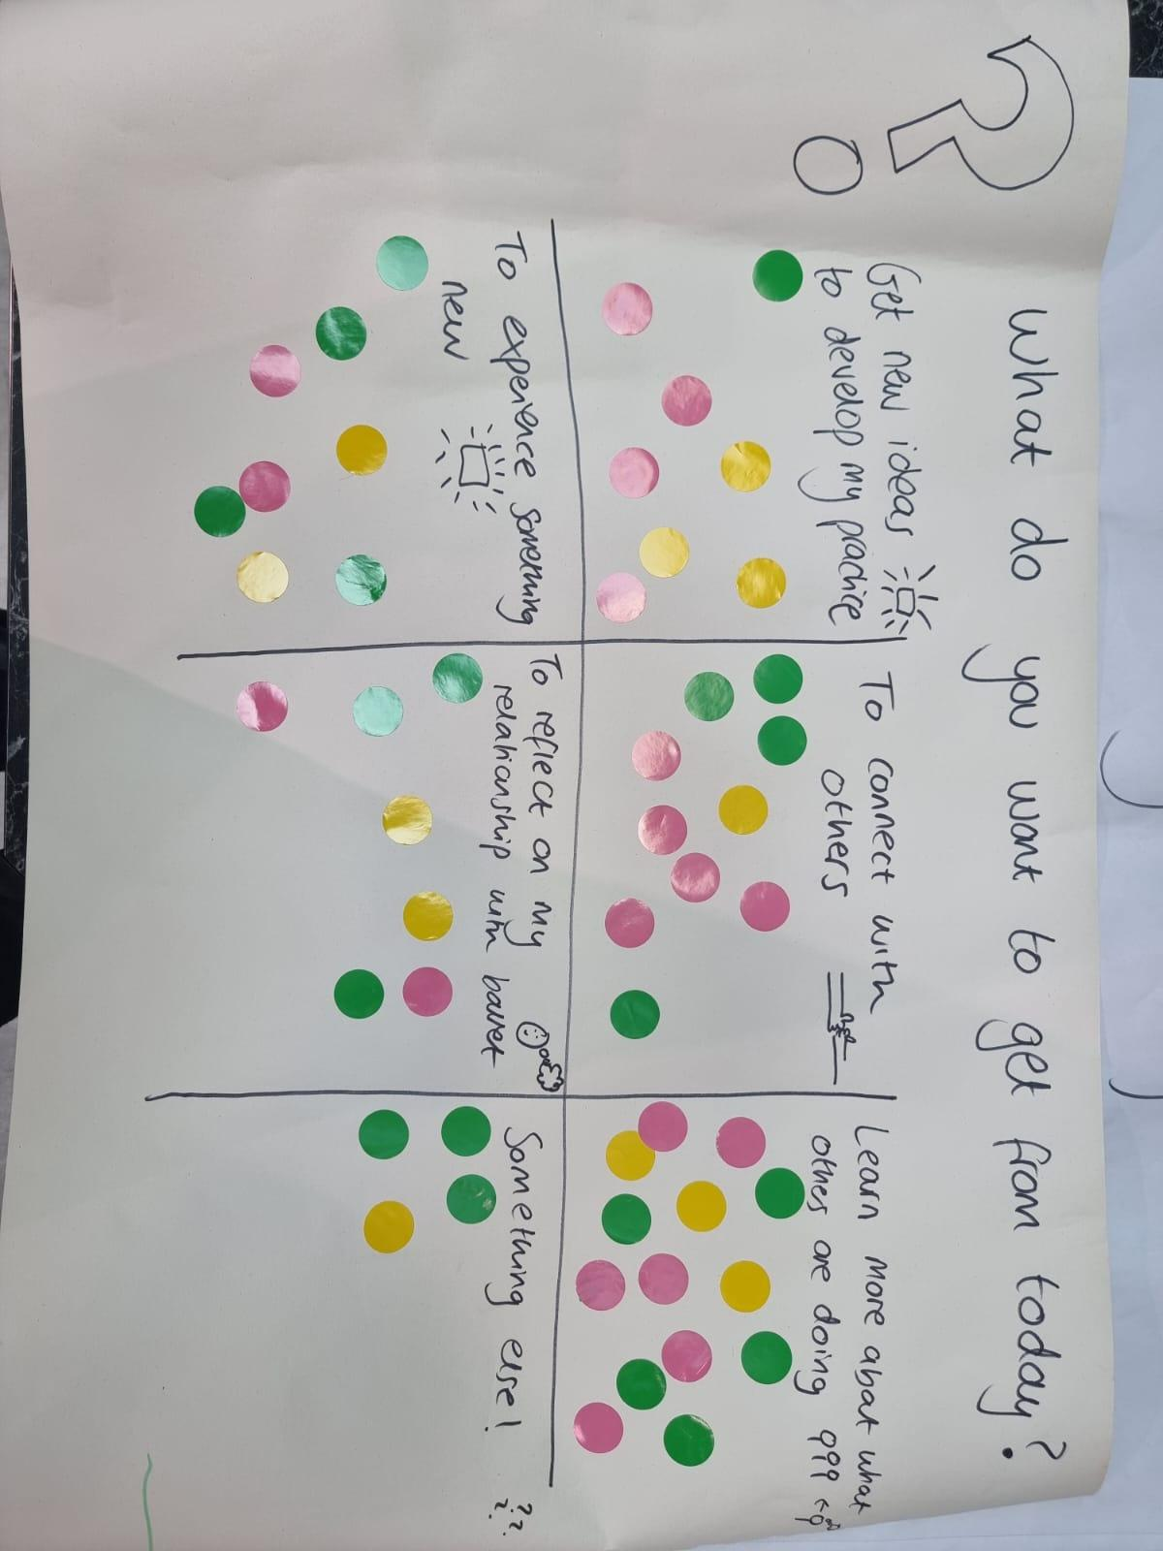

- Get new ideas to develop my practice - 8 dots
- To connect with others - 10 dots
- Learn more about what others are doing - 14 dots
- To experience something new - 8 dots
- To reflect on my relationship with ballet - 7 dots
- Something else! - 4 dots

Appendix B - Postcard Feedback (end of the day)

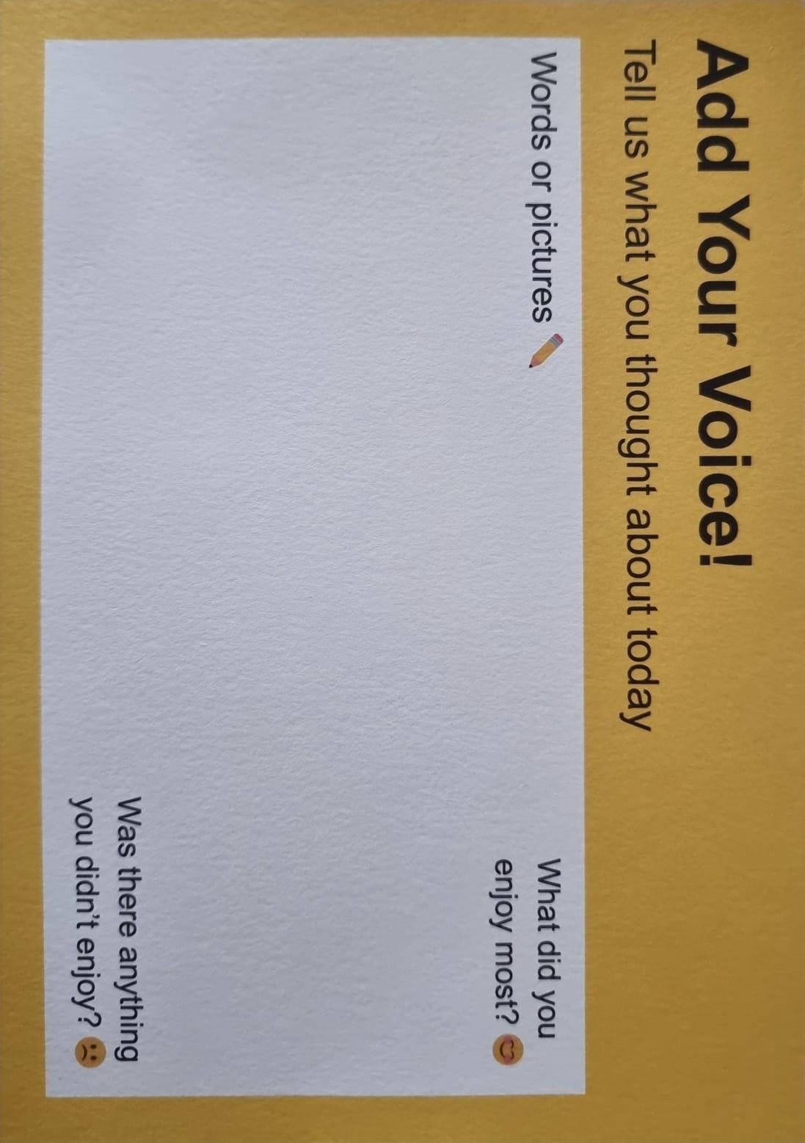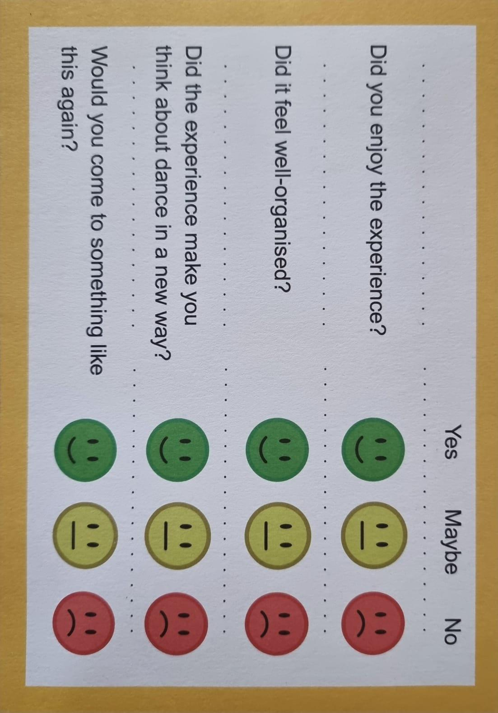

Number of Completed Postcards: 28

Smiley Face Data:
- Did you enjoy the experience?
  - Green (Yes): 28 | Yellow (Maybe): 0 | Red (No): 0
- Did it feel well-organised?
  - Green (Yes): 27 | Yellow (Maybe): 1 | Red (No): 0
- Did the experience make you think about dance in a new way?
  - Green (Yes): 17 | Yellow (Maybe): 2 | Red (No): 0
- Would you come to something like this again?
  - Green (Yes): 28 | Yellow (Maybe): 0 | Red (No): 0

Overall Experience & Impact:
· "I thought today was a great balance of practical + talking + learning!"
· "I thought today was Really inspiring, I loved it all the different ways to look at movement I found it really thought provoking. I also really enjoyed listening and I learnt a lot about everyone. Meeting lots of cool people. Very heart warming overall important - thank you!"
· "Good fun + thought provoking. Ready for the next one"
· "Excellent day - learnt lots! looking forwards to the next one"
· "Inspiring"
· "Thank you so much for all the thought & inspiration"
· “Taking the day to learn and not have to lead the room and just be”
· “Thought provoking”

Inclusivity & Community:
· "Just being in the space where everyone was included as the default - it's not always like this at conferences"
· "Have so many people from different backgrounds with different ideas of how we can make ballet & more inclusive and where (it's) great!"
· "It was lovely to be in the room with so many people who are passionate about the same goal of inclusivity"
· "Being in the room with so many people who are passionate about the same goal of inclusivity"
· "I have connected with our community again & hopeful for the future of inclusive ballet"
· "So many activities were fab amazing people! Developing inclusive thinking further & meeting others like me :)"
· "Activities were fab amazing people! Developing inclusive thinking further"
What People Enjoyed Most:
· "Human Connection"
· "Mix of practical + discussion"
· "I enjoyed exploring moving in a different way but using ballet steps as a base"
· "practical experience dancing with different dances"
· "learning and discussing new ideas and stuff with people"
· "connection inclusivity Joy amazing facilitation"
· "Moving with lots of different bodies but with the same intention"
· "Taking the day to learn and not have to lead the room and just be"
Organisation & Accessibility:
· "Inclusive environment. Well organised. Good use of verbal and visual aids."
· "I really appreciate all the access consideration that was put into organising the day - easy read what to expect, who will be there, etc"
· "Like been bags, lunch was good, like performance, BSL Good, Acoustics okay"
· "I felt so comfortable to be myself… use of Makaton was a game changer… consideration of resources was fantastic and advanced information about what to expect was fantastic, properly anxiety reducing. Everyone’s hosting was 10/10. I have not stopped smiling”
Impact on Perspective:
· "I already look at dance in an inclusive way, today helped me to view ballet differently"
· "Ballet is not the same as dance, + the focus was too much on ballet felt strong, relevant + vital"
Future Aspirations:
· "Would love to expand knowledge even more people wheelchair skills"
· "I would love to see this grow and live on large beyond first"
· “We need another day like this"
Areas for Improvement:
· "The dark room & light"
· "lack of space in dance area"
· "I would prefer things in smaller groups"
· "I would have appreciated a note on what kind of clothing might be appropriate for the day"
· In evaluation, a couple of respondents specified that ballet wasn’t the same as dance (responding to the question on the postcard that asked if ‘Did the experience make you think about dance in a new way?’. Would look to create more event-specific evaluation postcards if doing again.

Appendix C - End of the Day: One Word to sum up the day

· Community
· Connection
· Considerate
· Inclusive
· True
· Thought-provoking
· Nourishing
· Future proofing
· All In
· Powerful
· Caring
· Impressive
· Hard Work
· Very Good
· Great
· Shared vision
· Joy

Appendix D - Post It Note Tree

Task:

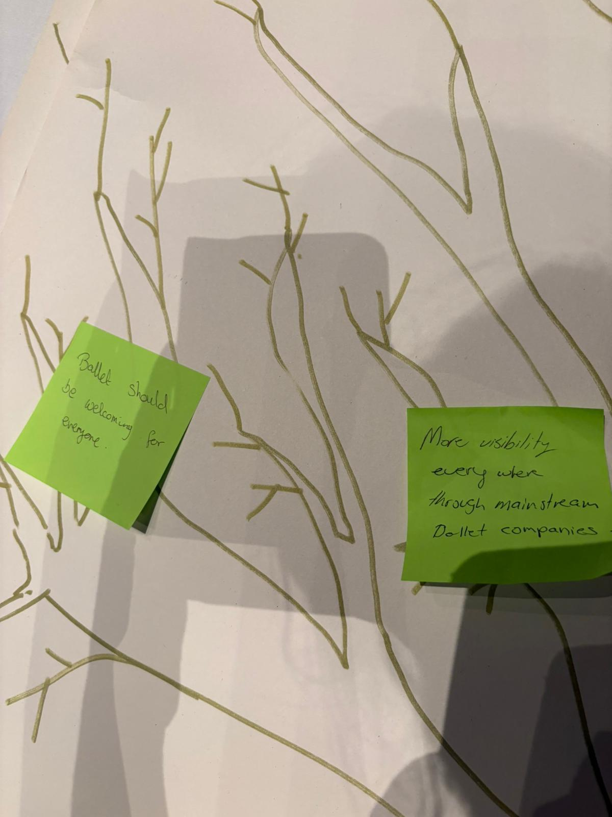

Outcomes:

- "lets not change Ballet just adapt it"
- "Ballet should be welcoming for everyone"
- "More visibility everywhere through mainstream Ballet companies"
- "Change takes generations - take courage that you/we are making a difference + keep going"
- "Does the public's perception of ballet need to change first or alongside changes in industry?"
- "dancers, makers + leaders who can find a career path with only disabled if we want, mainly non-disabled or both"
- "let's let go of the 'ballet body’
- "BOTH inclusive 'Nutcrackers' AND new works - a full ballet ecology of disabled + non-disabled dancers, makers + leaders"
- "The ballet I see is Elitist"
- "I wish to see more people from all backgrounds on stage (mainstream)"
- "IN THE STUDIO let go of binaries in general NOT EITHER/OR. There are dancers their range of movement + ways of communicating"
- "IN THE WORLD acknowledge that disabled/non-disabled still exists, still do what's needed to get all in the studio"
- "I just love the question 'How can we respect history without repeating exclusion?' lets ask it MORE LOUDLY + MORE OFTEN!!"

Appendix E - Ballet Wish Tree

Task:

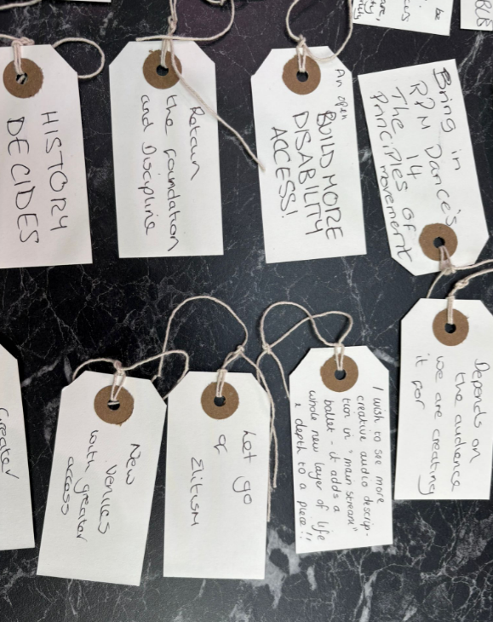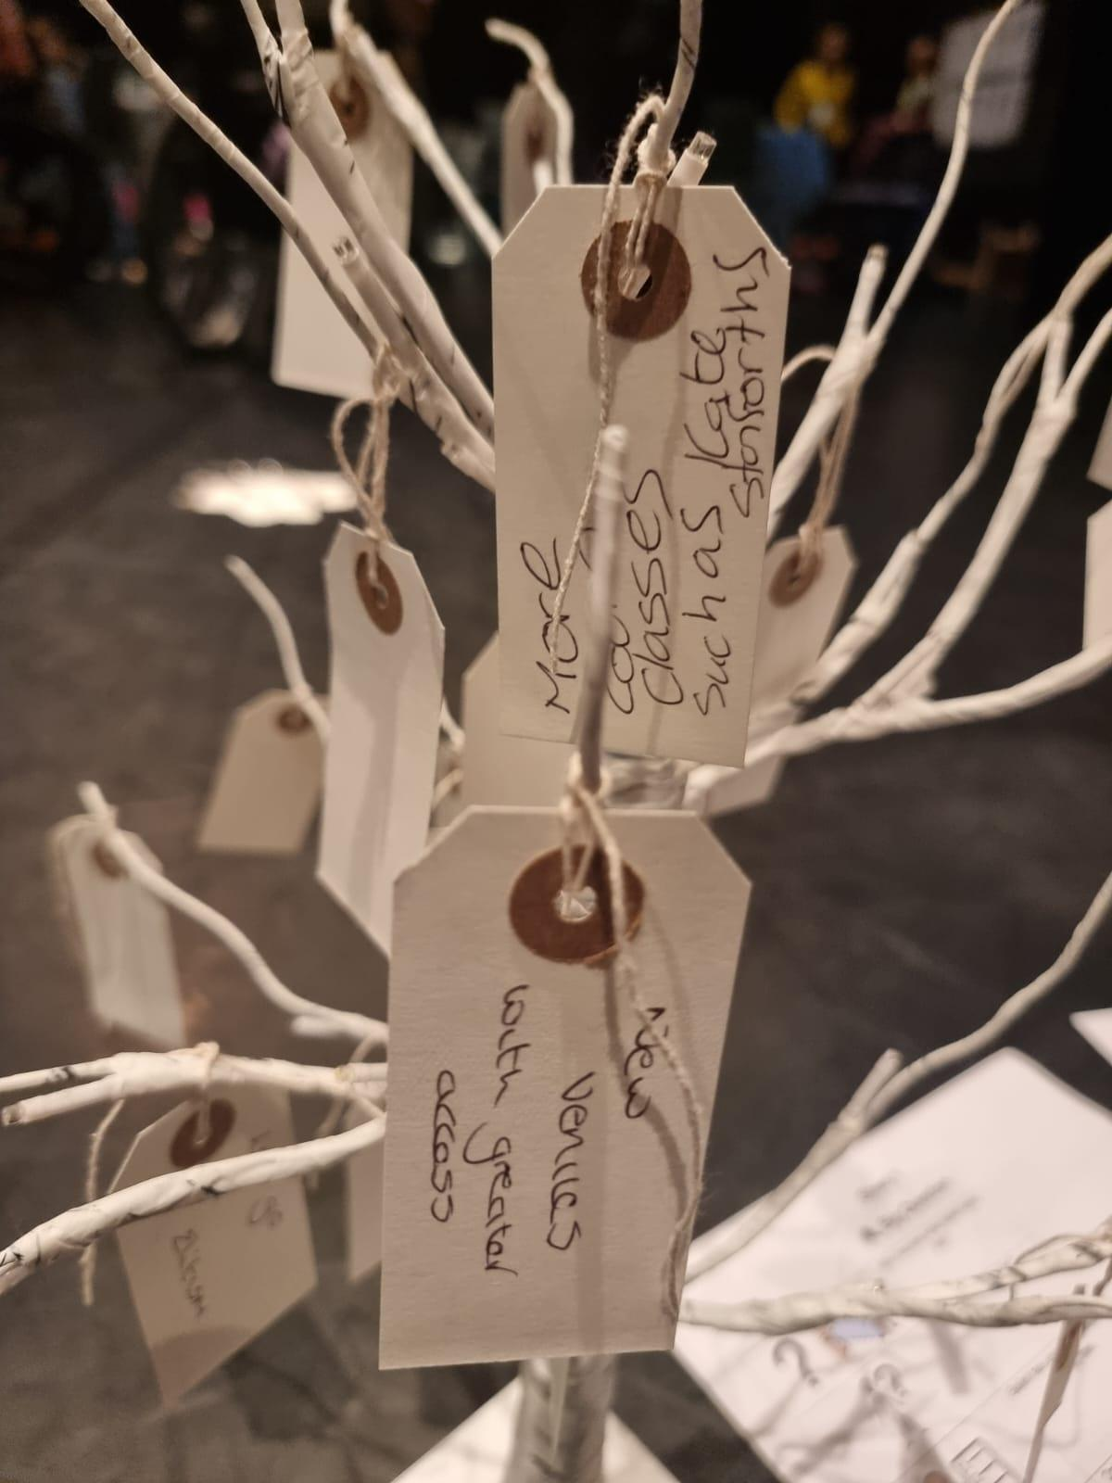

Outcomes:

- Diverse minds and bodies
- Ehlers-Danlos Syndrome
- Ballet is a place where everyone can achieve success
- Adapt Ballet
- More things into school
- Every body
- I wish ballet and dance was healthy for everyone. Focus on the wellbeing of dancers, humans first, product second.
- Ballet is for all, I wish for the style to be more inclusive in class, stage and life.
- Bring in RPM Dance’s The 14 Principles of Movement
- Build more disability access!
- Depends on the audience we are creating it for.
- I wish to see more creative audio description in ‘mainstream’ ballet - it adds a whole new layer of life and depth to a piece!!
- Let go of elitism.
- Retain the foundation and discipline.
- History decides.
- New venues with greater access.
- More zoom classes such as Kate Stanforths.
- I don’t truly know which bodies and stories are missing from ballet because it is inaccessible to me for watching.
- Diverse Minds and Bodies.
- Keep prestige and glamour. Make it accessible to all!!
- I wish for ballet to be more person centred. To acknowledge dancers are humans and not machines. To value care, diversity and individuality that can come together in unity.

Appendix F - Is the goal to add people into ballet, or to change ballet itself?

Task:

In a small group, participants answered the following questions:

Is the goal to add people into ballet, or to change ballet itself?
• Inviting more people is great, but are we inviting them into an old system?
• Maybe ballet needs to change its values as well as its doors.
• Let’s talk about what we keep and what we let go.
• What do we need to let go of to make ballet open to everyone?
• What new things do you wish ballet would value?
• How can we respect history without repeating exclusion?

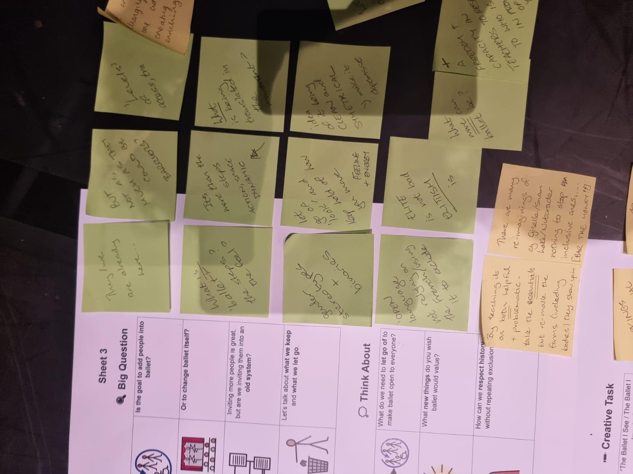

Outcomes:

- They are already here… but not as much as they could be. Barriers? ‘Levels’ of access, training.
- We are not changing, we are adapting, creating a more enriching style.
- What is ballet? The steps? The feel?
- It’s more than the steps. Action, space, dynamic.
- What is being translated in the movement?
- It can take care of injury prevention but all bodies are different (so it must work for you).
- Making ballet fit for your body, not fit your body to ballet.
- Not water down. Find the essence and keep the richness.
- Gender stereotypes and binaries.
- Let go of ‘look’ and keep hold of how you move. Feeling and energy.
- Idea of it being clean and symmetrical. Make it expansive.
- Let go of perfectionism - flaws are interesting.
- Open language. Not relying on the French/using it to exclude.
- Elite is not bad, elitism is.
- What more can ballet be?
- A freedom and capacity in teachers to respond to who is in front of you.
- Open-ness.
- Disabled teachers and role models. Film and digital is powerful in this.
- Value collaboration with professionals at high level.
- Value the intent of movement and charisma.
- Value experienced disabled dancers and their experience supporters.
- History - by teaching it as both helpful and problematic. Take the essentials but re-make the forms (including bodies) they show up in.
- There are many re-imaginings of, e.g. Giselle, Swan Lake, Nutcracker, nothing to stop inclusive ones (bar the money!!)
- Re-workings of traditional ballets with a disabled lens and new ballets by disabled choreographers.

Appendix G - If access is not an add-on, how do we build ballet from the ground up?

Task:

In a small group, participants answered the following questions:

• What if ballet was easy to join from Day 1?
• What if everyone felt safe, seen, and ready to dance?
• Let’s plan a ballet class that starts with access at its heart.
• What has helped you or your students feel good in dance?
• Picture the first five minutes of an accessible ballet class, what happens?
• How can we teach so that different brains and bodies can learn together?

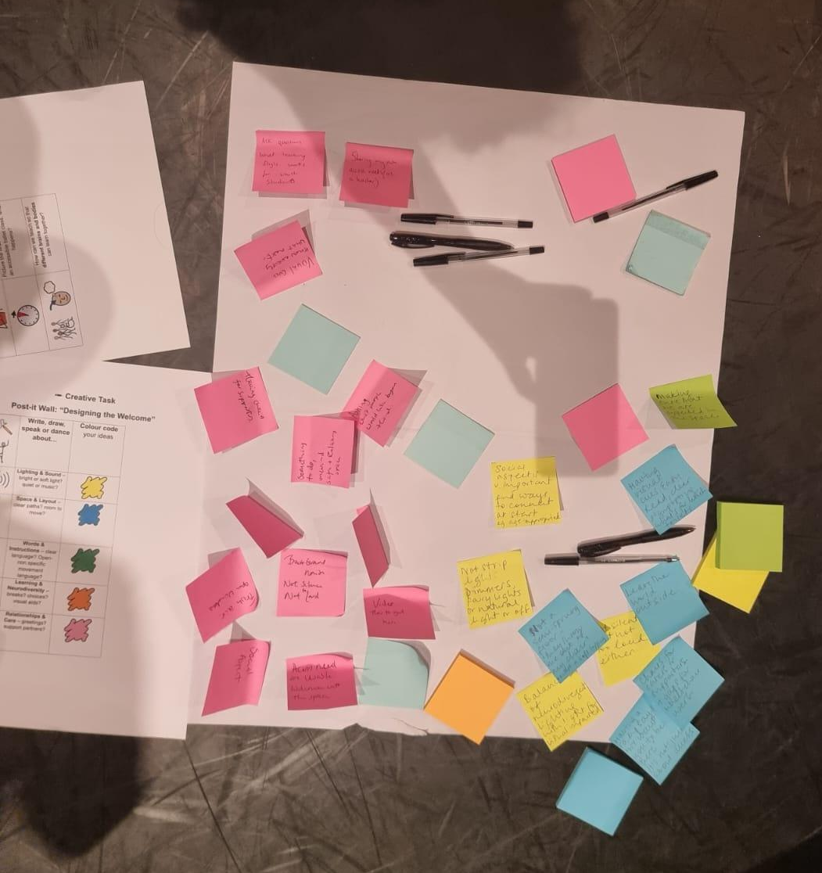

Outcomes:

- Sharing my own access needs (as a teacher)
- Ask questions. What teaching style works for which students.
- Visual cues. Know exactly what’s next.
- Safe and relaxing space.
- Having choices for supporters.
- Background noise. Not silence. Not too loud.
- Video how to get here.
- Fresh air. Open windows.
- Social aspect.
- Access needs are welcomed into the space.
- Social aspects v. important. Find ways to connect at the start (age appropriate).
- Not strip lights. Dimmers, fairy lights or natural light or off.
- Not a semi-sprung floor - they throw me out of my chair (i.e. not a soft topping)
- Balance of neurodivergent lighting with light for visually impaired.
- Leave the world outside.
- Having visual cues, easy read, clear signposting, toilets, what’s for lunch
- Chair for carers or supporters and gaps for wheelchair users
- Having a ramp says ‘we want you to be here’, it’s not just about access
- Making sure that we are expected in the space

Appendix H – Ballet Collages

Task: Use pictures, articles and posters to imagine what ballet could look like.

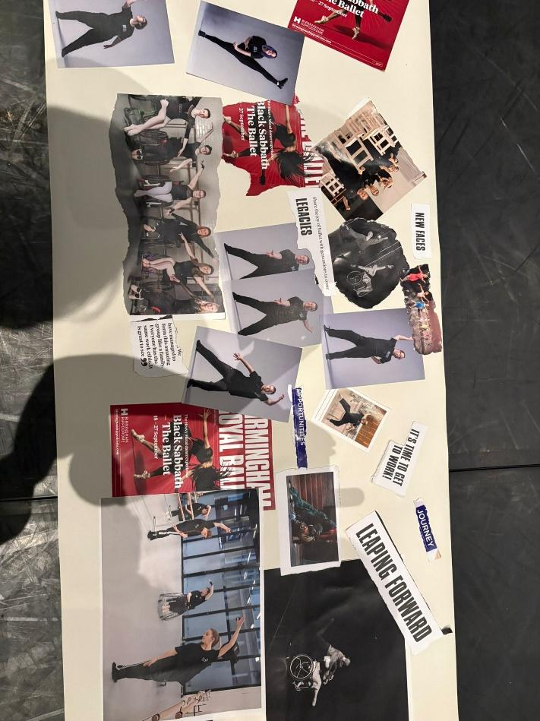
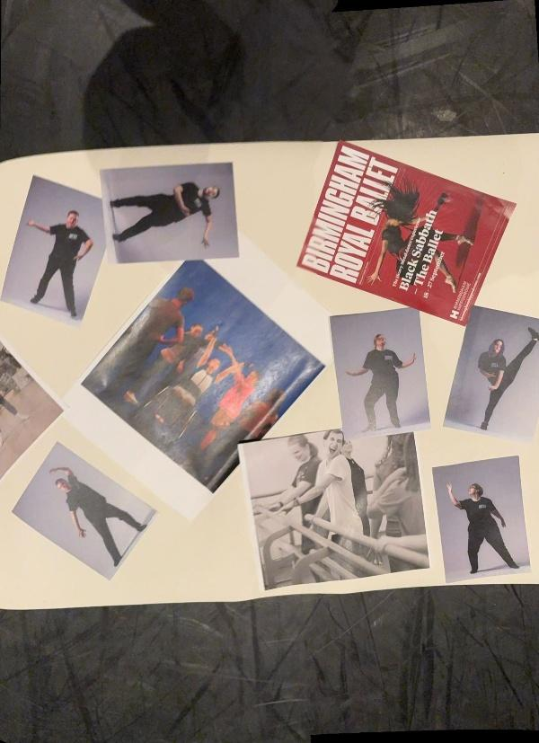

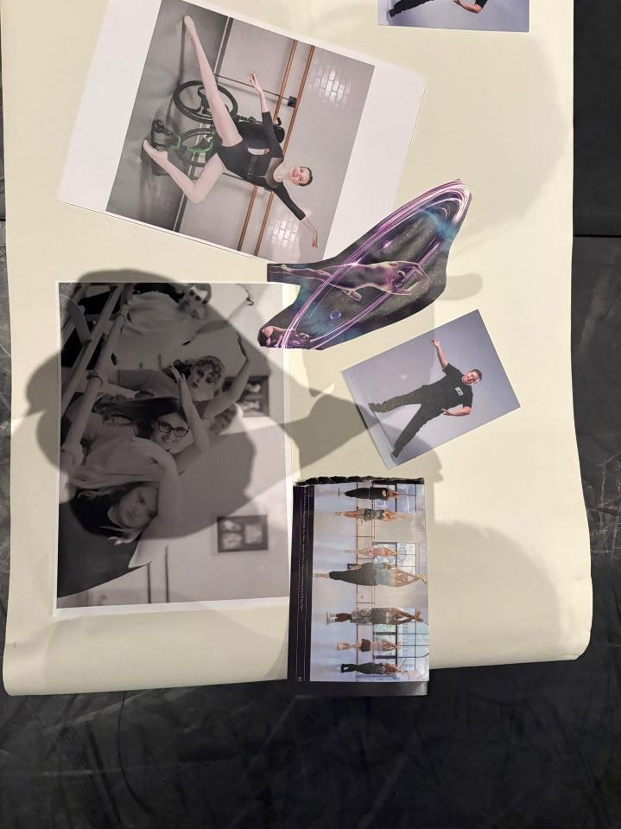

For more information on Universal Design and its application in ballet, Suzie Birchwood has written a series of articles including: https://suziebirchwoodconsultancy.com/blog/beyond-the-ramp-universal-design-in-ballet https://suziebirchwoodconsultancy.com/blog/include-diverse-bodies-group-choreography-find-your-engine https://suziebirchwoodconsultancy.com/blog/speaking-about-disability-with-confidence-language-universal-design-and-inclusion https://suziebirchwoodconsultancy.com/blog/the-ballet-pli%C3%A9-exercise-a-universal-design-approach

