National Youth Ballet’s Summer Courses auditions are now open!

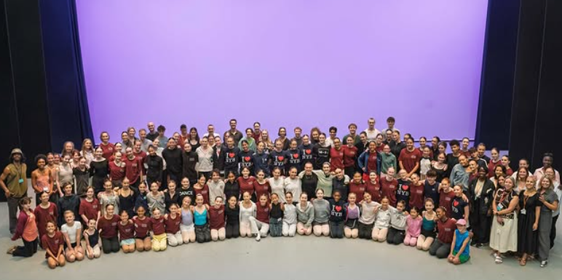 | Auditions are open for our NYB All In! Performance Company
 | The course helps you to be creative
 | The course helps you collaborate with other dancers
 | The course gives you performance opportunities

Residential Performance Company
 | The All In! Performance Company is a performance opportunity
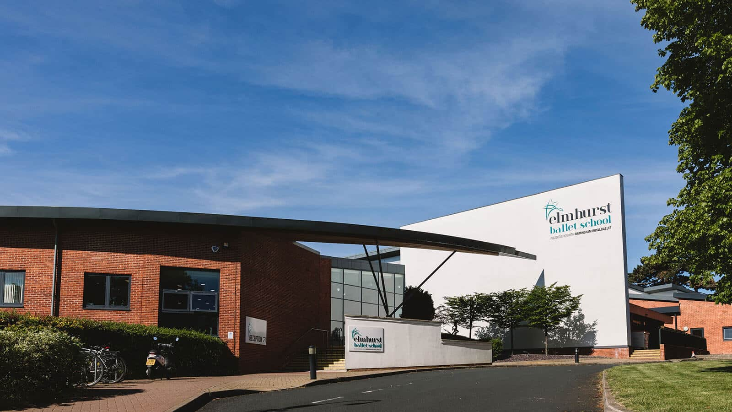 | You will take part in intensive rehearsals non-residential at Elmhurst Ballet School
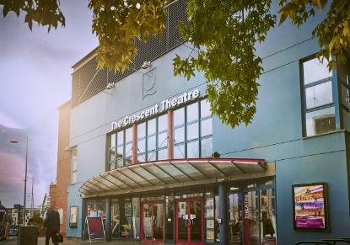  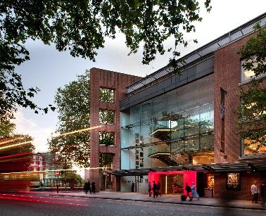 | And then perform at Birmingham’s Crescent Theatre and London’s Sadler’s Wells Theatre
  Age: 16-30 | Open to dancers aged 16-30
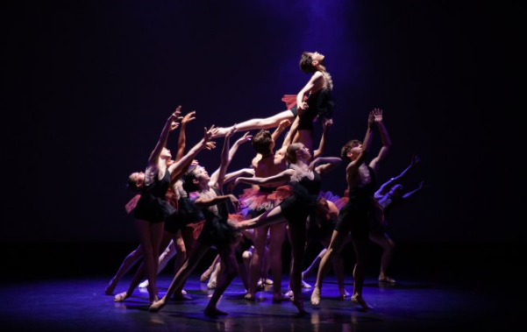 | Dancers will have good technique and performance skills
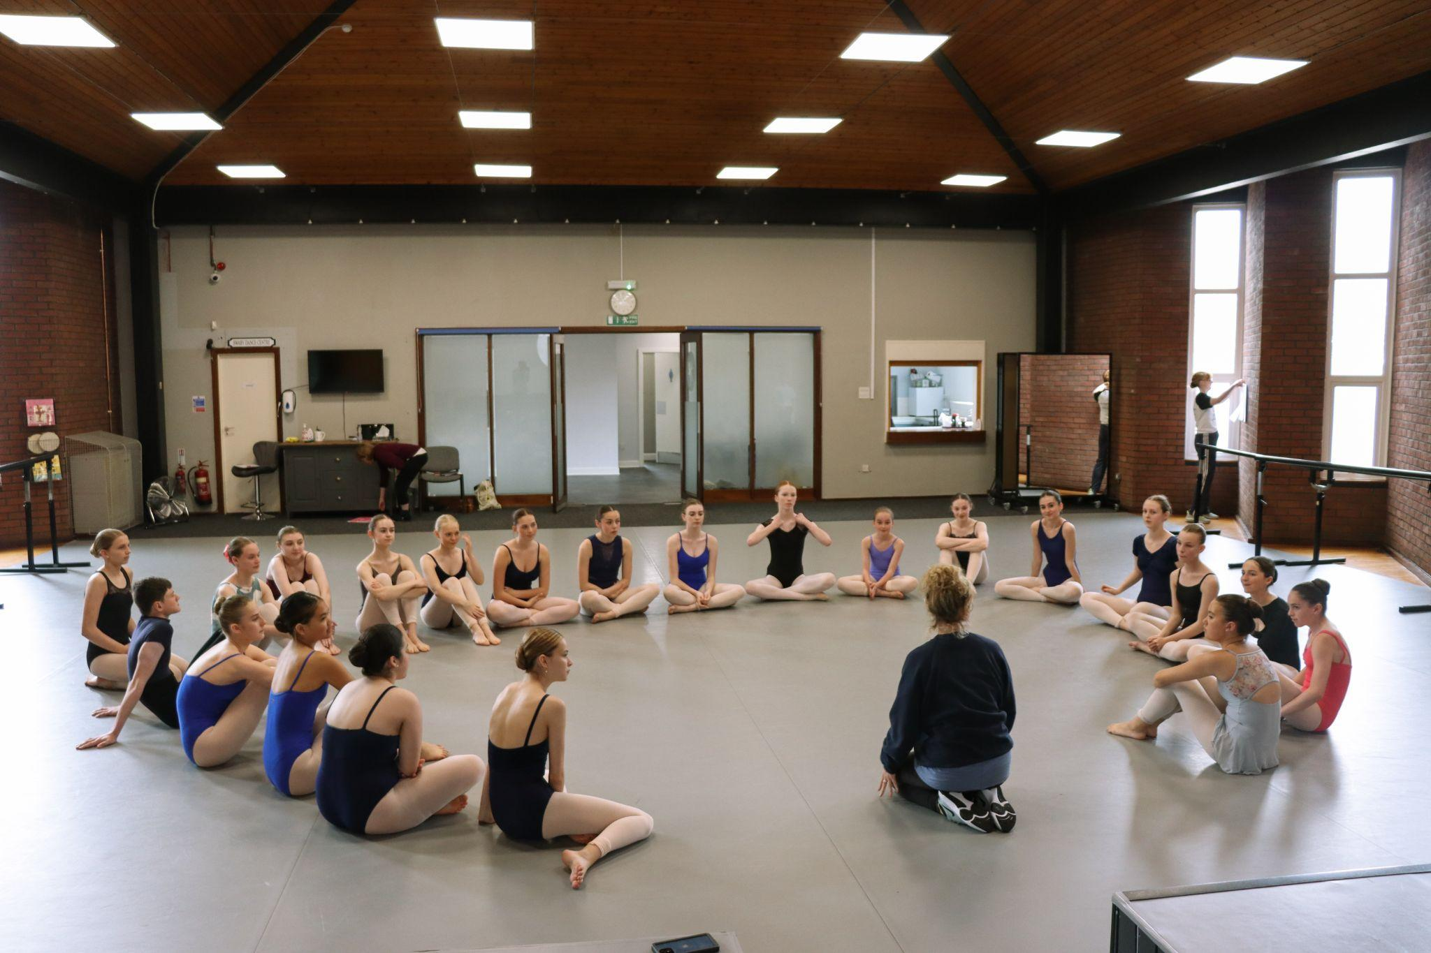 | Dancers will experience what life is like in a professional ballet company
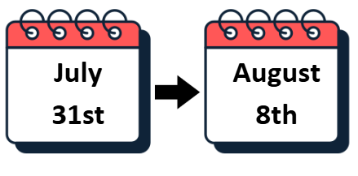 | The dates at Elmhurst are:  Wednesday August 5th – Saturday 8th August 2026  (10-13 year olds to attend Sunday 2nd August – Saturday 8th August 2026)
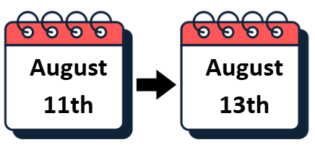 | Rehearsals and Performances at the Crescent Theatre, Birmingham will take place:  Tuesday 11th August – Thursday 13th August 2026
 | The gala performance at Sadler’s Wells Theatre, London will take place:  Saturday 5th September 2026

Course Fees
 | Course Fees are listed on the audition information webpages
 | You can apply for a bursary to help with the cost of taking part
 | You can find out more information about bursaries on the NYB website

Support and Access
 | If you need any support with completing an application form please contact us at natalie.haslam@nationalyouthballet.org.
 | There is a space for you to share your additional access needs within our form
 | We welcome any access riders via the email address above

